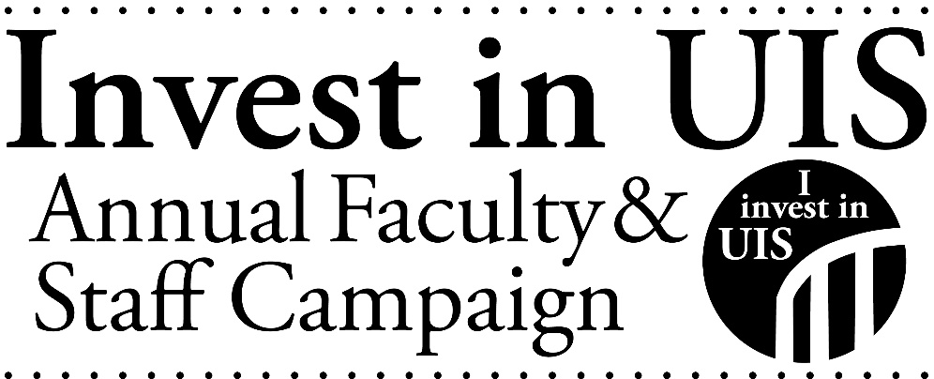
Where UIS Employees Gave in Fiscal Year 2021 (all funds)

Academic Affairs Fund for Excellence
Alternative Spring Break
Ann Orr Carlson Education Scholarship
Art Students League
Astronomy
Athletics Unrestricted Fund
Bill and Frances Cosgrove Water Resource Management Scholarship
Biology
Black Student Union
Business Administration
Campus Recreation
CAP Honors Study Away Scholarship
Carol and Clark Esarey Endowed Scholarship
Center for Academic Success and Advising
Center for Online Learning, Research and Service
Chancellor Susan and Dennis Koch Excellence in Athletics Endowment
Chancellor's Fund for Excellence
Cheerleading
Child Advocacy Residential Simulation Lab
Child Care Center
Christian Student Fellowship
Clarice Ford Fund
College of Business and Management Scholarship
College of Business and Management Scholarship
College of Education and Human Services
College of Liberal Arts and Sciences
College of Public Affairs & Administration
College of Public Affairs & Administration Scholarship
College Republicans
Communication
Cross Country-Men's
Cross Country-Women's
Diversity Center
Donald F Stanhope Alumni Scholarship
Donald O'Neal Scholarship
Dr. Clarice Ford "Whatever It Takes" Fund
Educational Leadership
Field Station at Lake Springfield
Field Stations
Friends of Brookens Library
Friends of Emiquon
FRIENDS of UIS Performing Arts Center
Gender and Sexuality Student Services
Global Experience Scholarship
Good as Gold Ceremony
Graduate Public Service Internship
Harry and Deborah Berman Faculty Sabbatical Endowment
Harry and Deborah Berman Sabbatical Fund
History
Human Development Counseling
Human Services
Illinois Innocence Project
Information Technology Services
Innovate Springfield
Intercollegiate Baseball
Joe Wilkins Veterans Scholarship
Jordan Social Justice Scholarship
Julie and William Kellner Working Student Scholarship
K Fund
Landscape and Garden Fund
Lawrence E. Williams/Dr. Larry Golden IL Innocence Project Scholarship
Learning HUB
Leonard Branson Accountancy Scholarship
Library Fund
Lincoln Legacy Lecture Series
Lincoln Studies
Lucchesi Family Scholarship
Malcolm and Amy Levin Scholarship
Mathematical Sciences
Maureen A. Schaaf Scholarship
Medical Laboratory Science
Men's Basketball
Men's Golf
Men's Soccer
Men's Tennis
Military/Veterans Emergency Grant
Model United Nations
Music
Naomi and Robert Lynn Distinguished Capital Scholars Fund
Necessary Steps Mentoring Program
NPR Illinois
NPR Illinois Quasi-Endowment
Office of Disability Services
Our Stage Our Voice Program
Police Department
Public Affairs Reporting
Ringeisen Scholarship
Rosie Richmond Scholarship
Sangamon Experience
Schweighauser Astronomy Fund
Shelterbelt Reading Series
Staff Scholarship
Student Affairs Fund for Excellence
Student Chapter of the Society for Advancement of Management
Student Union Building Fund
Students Transitioning for Academic Retention and Success
Suzanna Kay Shiner Scholarship Endowment
Terri Jackson Book Award
The Stars Supply Stop
Theatre
Theatre Scholarship
UIS Cares Food Pantry
UIS Fund
UIS Scholarship Fund
UIS Women's Center
Undergraduate Student Research
Violet Rose Salela Music Scholarship
Visual Arts Gallery
Volunteer and Civic Engagement Center
Women's Basketball
Womens Golf
Women's Soccer
Womens Softball
Womens Tennis
Women's Volleyball

