**Department of Environmental Studies**

**University of Illinois at Springfield**



**Graduate Student Handbook**

**Revised June 2022**

Master of Science in Environmental Sciences

Graduate Certificate in Geographic Information Systems

**Table of Contents**

**About the Department 1**

**Personnel 3**

**Requirements for Master’s Degrees 5**

**Education Plan 7**

**Advising Sheets 8**

**Course Rotation Schedule 8**

**Overview of Closure 9**

**Thesis and Graduate Project 11**

**Capstone Closure 16**

**Overview 16**

**Internship Guidelines 16**

**Internship Plan 19**

**Master’s Degree Limitations 21**

**Appendix I. Advising Information Sheet 22**

**Appendix II. Education Plan 24**

**Appendix III. Proposal Approval Sheet 28**

**Appendix IV. Capstone Internship Supervisor’s Evaluation Form 29**

**Z:\Advertising\EnvironmentStudies_stacked.eps**

**University of Illinois at Springfield**

**Department of Environmental Studies**

**About the Department**

The mission of the Department of Environmental Studies (ENS) is to provide students with the advanced interdisciplinary training necessary for solving environmental problems. Faculty members with diverse backgrounds in the social and natural sciences and in the humanities are committed to developing interdisciplinary approaches to environmental problem solving.

The curriculum is designed for students to gain an understanding of ways to evaluate the impact of human activities on the environment and human health, to balance social and economic needs with environmental realities, to learn how to use resources imaginatively for sustained yields, and to become aware of the role of values in issue formulation and policy making.

Our curricular objectives include the ability:

* to critically analyze environmental issues;
* to research environmental problems and their impacts;
* to evaluate human interactions with the environment; and
* to compare, contrast, evaluate, and implement solutions that facilitate a sustainable future.

**History**

Groundbreaking for Sangamon State University (SSU) began in 1970 and classes started that same year. SSU was founded as one of two Illinois senior campuses – having upper division undergraduates and graduate students, but no freshmen or sophomores. (This was done in anticipation of a greatly expanded community college system in the state.) SSU became the third campus of the University of Illinois in 1995. It wasn’t until 2001 that UIS began admitting freshman, and at that point enrollment was restricted to those accepted into the Capital Scholars Honors Program. Regular admission for freshman and sophomores started in 2006. Today UIS enrolls about 5,000 students, is the highest rated public regional university in the state by US News and World Reports, and is the only Illinois institution that is a member of the prestigious Council of Public Liberal Arts Colleges. The campus has become an international leader in online education, having received more individual and campus awards from The Sloan Consortium (Individuals, Institutions and Organizations Committed to Quality Online Education) than any other campus on Earth.

The Department is one of the oldest environmental studies departments in the United States. When our campus started (as Sangamon State University), the Environments and People Program was one of the original degree offerings in 1970. (The oldest such department in the US was formed in 1965.) ENS has previously offered an undergraduate degree which was dropped to allow the department to focus on graduate education. A few years ago ENS created an undergraduate minor and last fall we revived the BA program. At the graduate level ENS used to have an MA in Energy Studies and MA in Environmental Studies, and currently offers an MS in Environmental Science and a Graduate Certificate in GIS – both of which can be completed fully online.

Courses offered and degree names have changed, enrollments have waxed and waned, but ENS is currently in a period of unprecedented growth. The number of graduate students has grown quickly in the last decade, and we now tend to alternate with one other campus for the largest number of graduate students in environmental sciences. The number of students completing their master’s degree annually has increased more than six-fold in the past decade. In Summer 2009 ENS had two faculty members. One the next page you can see how we’ve grown! More growth is planned, and we are glad that you have chosen to join us.

**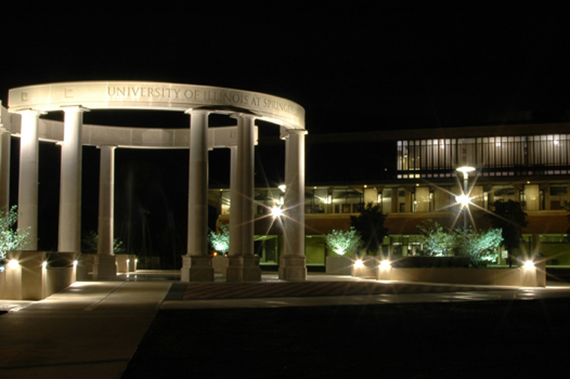**

**Core Faculty**

**Kyle Blount** – Assistant Professor. PhD – Hydrology, Colorado School of Mines; MS – Hydrology Colorado School of Mines; BS – Environmental Geosciences; Previous: Postdoctoral Research Associate, School of the Environment, Washington State University.

**Brandon Derman** – Assistant Professor. PhD – Geography, University of Washington; MA – Geography, Hunter College, City University of New York; Certificate in Geographic Information Systems and Science – Hunter College, CUNY; BFA – Video/Multimedia – Hunter College, CUNY; BA – Context of Urban Design and French, University of Michigan.

**Anne-Marie Hanson** –Associate Professor. PhD – Geography, University of Arizona; MS – Latin American Studies, University of Arizona; BS – Anthropology and Spanish, Luther College. Previous: Visiting Assistant Professor, Trinity College, International Studies.

**Megan Styles** – Associate Professor. PhD – Anthropology, University of Washington; MA – Anthropology, University of Washington; BA – Anthropology and Environmental Studies, Washington University in St. Louis. Previous: Postdoctoral Teaching Fellow, University of Washington, Program on the Environment.

**Tih-Fen Ting** – Associate Professor. PhD – Natural Resources & Environment, University of Michigan; MS – Wildlife, Humboldt State University; BS – Biology, Tunghai University.

**Yun Zhao** – Assistant Professor. PhD – Geography, Oklahoma State University; MS – Geography, Oklahoma State University; BS – Remote Sensing, Nanjing University of Information Science and Technology.

**Affiliated/Emeritus/Adjunct Faculty**

**Harshavardhan Bapat** – Affiliated Associate Professor (UIS). PhD – Chemistry, University of Missouri, Columbia; MS, BS – Chemistry, University of Pune.

**Edward Hawes** – Professor Emeritus. PhD, MA – University of Wisconsin; BA – University of Pennsylvania. Previous: Instructor / Assistant Professor, Lake Forest College.

**Michael Lemke** – Affiliated Professor Emeritus (UIS). PhD – Biological Sciences, Michigan Technological Institute; MS – Cell Biology, University of British Columbia; BS – Biology, University of Wisconsin-Stevens Point.

**Malcolm Levin** – Professor Emeritus. PhD – Virginia Polytechnic Institute and State University; MS – University of Delaware; BA – University of Virginia.

**Amy McEuen** – Research Associate Professor (UIS). PhD, MS – Natural Resources & Environment, University of Michigan; BA – Biochemistry; Humanities, University of California, Berkeley.

**John Munkirs** – Professor Emeritus. PhD – University of Oklahoma; MA, BA – University of Missouri, Columbia.

**Melissa Pardi** – Assistant Curator of Geology, Illinois State Museum; PhD – Biology, University of New Mexico, Albuquerque.

**Thomas Rothfus** – Research Assistant Professor (UIS). PhD – Geophysical Sciences, University of Chicago; BSS – Geology, Cornell College.

**Charles Schweighauser** – Professor Emeritus. MA, BA – Williams College. Previous: Director, James S. McDonnell Planetarium.

**Desserae Shepston** – Adjunct Assistant Professor. PhD – Environmental Geography, Texas State University-San Marcos; MA – Biological Anthropology, Texas State University-San Marcos; Med – Curriculum and Instruction, Texas State University-San Marcos; BS – Psychology, University of Illinois at Urbana Champaign.

**Roy Wehrle** – Professor Emeritus. PhD, MA – Yale University; BS – Washington University.

**Requirements of Master's Degrees**

The first thing that most students want to know is what is needed to finish the degree. This handbook attempts to do so in both an abbreviated and detailed format. General requirements for MS and MA degrees are as follows:

* Be fully admitted as a degree seeking student. In some cases an applicant may be conditionally admitted. Those conditions must be completed within one year. If not, the student will no longer be eligible for financial assistance and the Department may request the offer of admission be rescinded.
* Have declared a major in one of our three concentrations
  + MS in Environmental Sciences, General Environmental Science
  + MS in Environmental Sciences, Environmental Planning & Management
  + MS in Environmental Sciences, Sustainable Development & Policy
* Complete required courses as listed in the UIS Catalog. The UIS Catalog lists course requirements for all degrees and corresponding regulations. UIS currently produces a new Catalog for each academic year, and you automatically fall under the rules of the Catalog in place during your first semester of enrollment. However, you can use the criteria for any subsequent Catalog if you want. This requires the completion of a Student Petition that the advisor and Department chair must approve.
* Complete required number of hours. Beginning in Fall 2010 all ENS students must complete a minimum of 40 credit hours. (Students first enrolling before then may need to complete additional hours. Check with your advisor if this applies to you.)
* Meet grading and GPA requirements. A minimum GPA of 3.0 is needed to graduate. All courses that can be taken for a letter grade must be done so. (This applies to all “traditional” courses, but not sections such as Thesis, Graduate Project, Graduate Research, Capstone, Tutorial, or continuing enrollment hours.) A maximum of 4 hours of C grades may be counted toward the degree if there is a corresponding number of A hours and an approved Student Petition is on file with the University.
* Complete closure exercise. MS degree candidates are required to complete a closure exercise demonstrating mastery of a specific area within Environmental Studies. The University of Illinois requires that all closure options have a significant writing component. In all departments, the closure exercises are commonly the most challenging part of the graduate degree. They require the integration and application of knowledge and skills acquired over your entire time in grad school. They require focus. They require considerable self-discipline. They require excellent organizational skills. They require hard work. It's never too early to start thinking about what you will choose for closure option. See page 8 for more information.
* Complete a graduation application. Early in the semester in which students intend to graduate they must complete a graduation application online. *If you miss the deadline, you will not graduate that semester*. Students should meet with their advisor to check on whether requirements have been met. The Graduation Office will check to see if you have any outstanding obligations and mail you a report. *Review that report closely because it will let you know if you are missing anything. It is your responsibility to correct any outstanding obligations.*
* Participate in the commencement ceremony (optional). A commencement ceremony is held every spring for students completing their degree requirements that spring or in the previous fall or summer. Students who have 4 credit hours or less remaining and anticipate completing those requirements in the following summer, can petition the University to be allowed to participate in commencement.

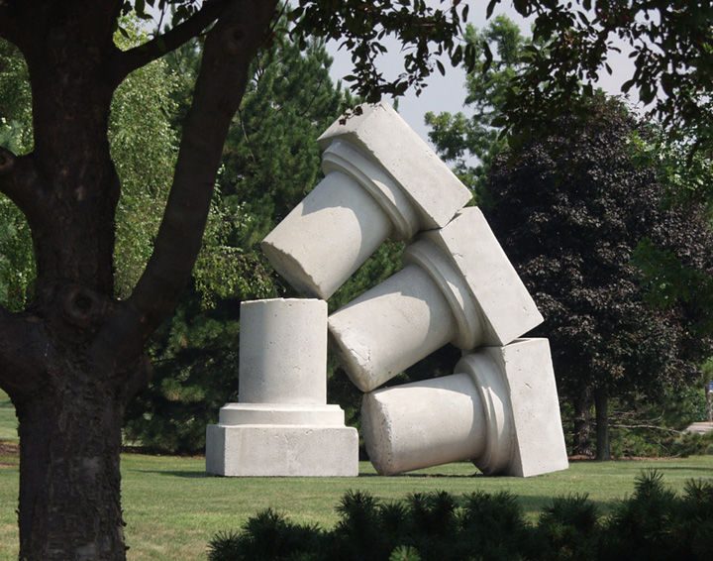

### Education Plan

The Education Plan requires making conscious decisions regarding your course, and overall academic, plans as you progress toward your MS. It also requires students to discuss their professional goals with their academic advisor, so that an appropriate plan can be created.

Based on the online course rotation schedule and appropriate Advising Sheet (Appendix I) students should complete the Education Plan (Appendix II) within three weeks of starting classes in the ENS graduate program. When there is a major change in the student's academic intents, a new Education Plan should be developed. Use the degree Advising Sheets and Course Rotation Schedule to create your Education Plan. While on-campus students can enroll in most online courses, they must take ENS 551, 552, and 553 on-campus.

The Education Plan requires the signature of the academic advisor and the department chair. An Education Plan can be found on the Department website and in Appendix II.

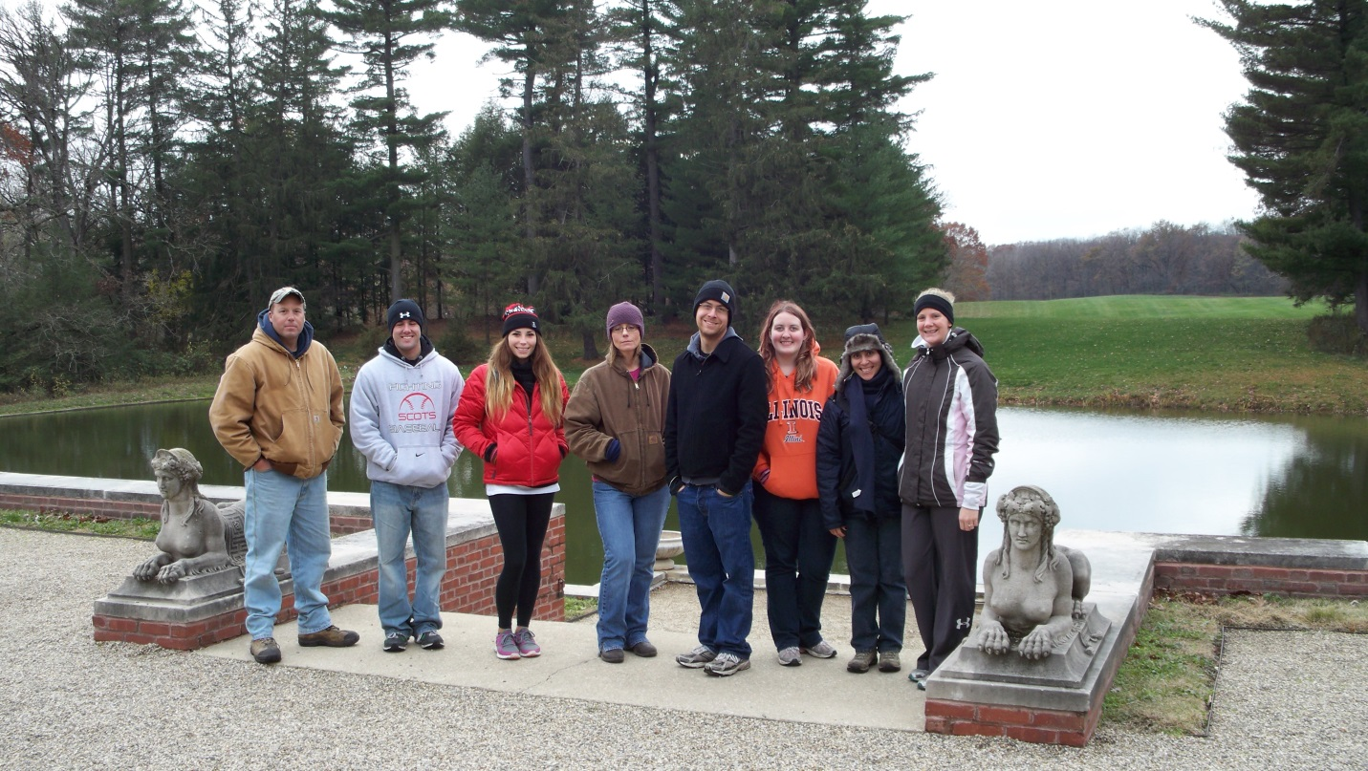

ENS trip to Allerton Park, 2012.

### Advising Sheets

Students are subject to the requirements of the UIS Catalog for the year in which they enter. Students also have the option of choosing the requirements of a subsequent active catalog for graduation. Switching catalogs requires a Student Petition approved by the advisor and Department chair.

The ENS Advising Sheets (Appendix I) are quick summaries of the required courses for each of the department's concentrations. See the UIS Catalog for a more detailed list of requirements.

Use the Advising Sheets and Course Rotation Schedule to help you put together your Education Plan. However, you are also urged to discuss other possible courses for your degree with your advisor. The ENS faculty wants you to be able to take the courses most appropriate for your career goals, and that sometimes means making small changes to the established curricula.

**Course Rotation Schedule**

The Course Rotation Schedule is the list of anticipated future offerings. However, keep in mind that changes sometimes occur due to student need and faculty availability. This is especially true of electives, but we have not needed to modify our common core or concentration course rotations in recent years. The schedule will be available on the department website and periodically revised.

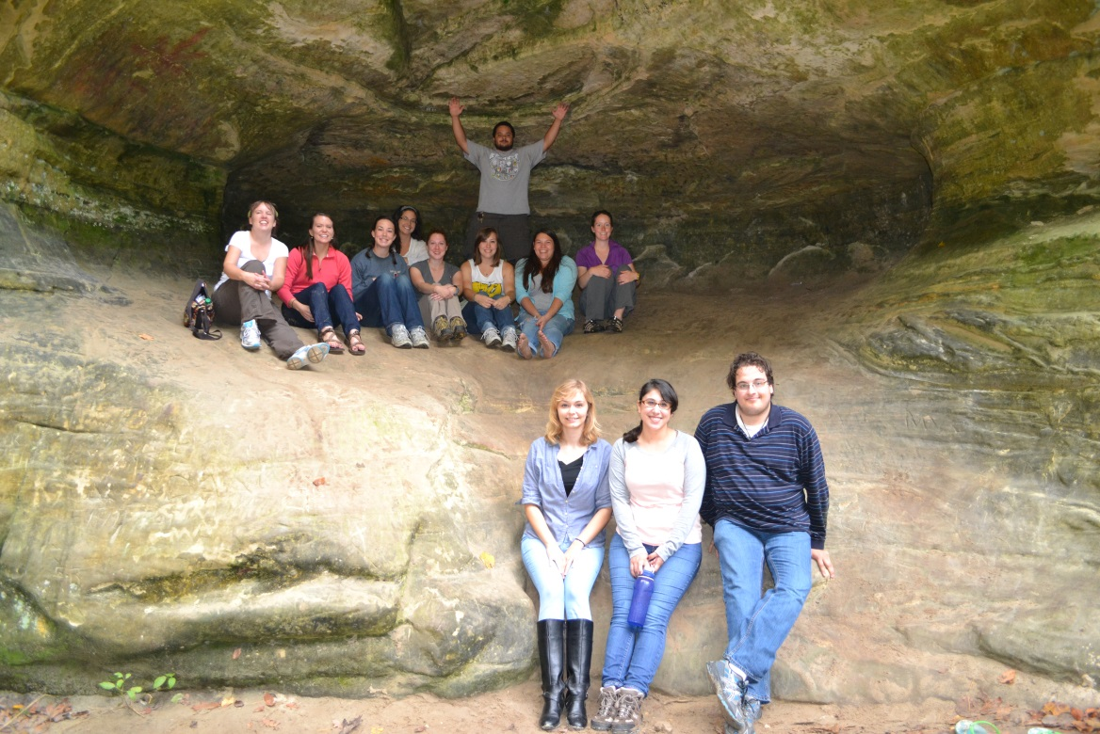

ENS at Starved Rock State Park, 2013.

### Overview of Closure

The University of Illinois requires all master's degree candidates to complete a closure exercise that demonstrates in-depth understanding of the field of study, and application of that knowledge. Although the exact composition of the closure exercise varies by department, all options must have a clear academic focus and a significant writing component. The Department of Environmental Studies currently has two closure options available for all master's students (Thesis and Graduate Project) and a third (Capstone Closure) for in the Sustainable Development & Policy and Environmental Planning & Management concentrations.

**Which closure option should I choose?**

ENS offers multiple options because students have different academic and professional goals. Basically, there's no easy answer to this question. The Capstone Closure will be appropriate for most students having the time (and facilities) available to commit to a substantial internship experience (which is the major course requirement). Students with research interests may want to choose either a Thesis or Graduate Project instead. The difference between these latter two options is relatively minor. A brief way of discriminating is that in a Thesis, students create new data; in a Graduate Project, existing data is examined in a new way or a creative product is made and placed within an academic context. All students should talk with their academic advisor before making any decisions regarding the closure activity.

**Is the Capstone Closure the easy option?**

Not necessarily. A Thesis and Graduate Project are product-focused options where you wind up with a document that you can put on a shelf. The Capstone Closure is process oriented, where the focus is on the experience. For most students the capstone route will be more time efficient; it is designed to be completed in one semester. In many cases it is that practical experience that is more attractive to potential employers. A Thesis or Graduate Project typically takes at least one semester to write the proposal, one or more semesters to complete the research, and one semester to write the Thesis / Graduate Project. However, if a student does not finish a Thesis / Graduate Project on schedule, she/he can enroll for the next semester and continue working. That is not an option for the capstone.

**What if I find an idea for a Thesis / Graduate Project, but can't find a research advisor?**

Then you will not be able to use that idea for a thesis / graduate project. There are multiple reasons why a faculty member might not agree to serve as your research advisor: no time available, no research expertise in that area, no confidence that the idea will work, the research will take too long, inadequate resources available for the research, and many others. You can either change to a different idea, or you can pursue the capstone course option (if you are an MA student). It might be a great idea, but every department at every university has natural limits to what it can support, and ENS faculty are obligated to only support research that can be done effectively.

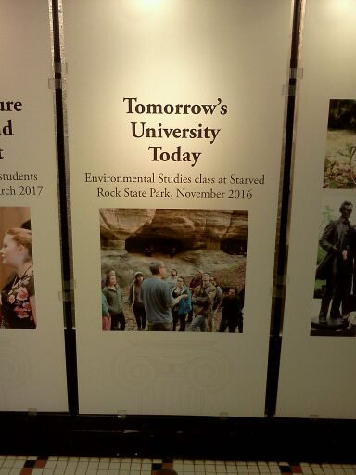

**Thesis / Graduate Project**

Both a Thesis and Graduate Project must be grounded in environmental studies coursework, and require mastery of literature within an identified area. A Thesis is an original contribution to environmental studies that has well-articulated methodology, exhaustively described findings and analyses, and results with implications for furthering theory and/or practice. A Graduate Project is a culminating activity that provides significant learning opportunities; this can be a major work dictated by the needs of a partnering organization (such as through your employer) or a creative final product. Students wanting to complete a thesis or graduate project MUST have a faculty member agree to advise the research before the student will be admitted to the program.

**Basic Structure of a Proposal**

Most proposals basically contain the same sections (below), with some added or deleted depending on the particular study. Lengths vary according to specific topic but are typically about 20 pages (not including Bibliography or Appendices). *Your research advisor's opinion is more important than this list, and each advisor may have her/his own thoughts on length and content. Talk to her/him before getting started and throughout the process.*

* **Cover page** – This separate page contains a short, descriptive title of the proposed thesis/project, author, department, institution, and date of defense.
* **Abstract** – This is a brief (<300 words) definition of the problem or goal addressed by your thesis/project and a description of your plan to explore/solve it. This is *your* planned work; no citations. (Write this last.)
* **Introduction** – The introduction section includes some combination of multiple possible elements:
  + What is the problem/issue being addressed, or what is the goal? Why is it significant?
  + What have others said about this specificproblem?
  + Give the theoretical perspective.
  + Establish definitions of terms as appropriate. (In some cases this is better done in the Literature Review.)
  + What are the deficiencies in past studies? What makes your work different?
  + Identify your purpose statement and research questions or hypotheses?
  + Note the limitations of your project.
* **Literature Review** – A good review will help convince the reader that you know the topic well enough to work in it, you are not doing something already done, and you are doing something worthwhile. Show that you understand how previously published papers relate to each other and to your work. As part of that, your quotations should be minimal; if you cannot rephrase in your own words, then you don’t understand the material. This should not read like an annotated bibliography with each paragraph simply summarizing an article. Instead your writing should integrate the points made by multiple studies.
* **Methods** – Explain, in detail, how you are going to carry out your work. What is the experimental design? How will you collect data? How will you measure, collect, analyze, quantify, qualify, and/or present data? What will you create? Use first person to make it clear what you will do as opposed to what was previously done by others you cited in the Literature Review.
* **Timeline** – Tasks vary, but common items on timelines:
  + completion of coursework
  + data collection
  + data analysis
  + first draft
  + presentation of results at professional meeting
  + defense of final Thesis/Graduate Project

Make your deadlines realistic. Remember that it will almost certainly take you multiple *good* drafts of your Thesis/Graduate Project before you are able to defend.

* **References** – All in-text citations must be in the References; all items within References must be cited in the text. Double check this before sending to your advisor by going through every citation and reference. With few exceptions, these need to be peer-reviewed journal articles or books. Identify a common style (such as APA) or find a journal in your specific area and use its format (with advisor’s approval). When you submit your proposal to your committee, let them know which format you used. Be very deliberate in making sure you have followed the format you say you’ve used. If you are unable to copy citation information correctly, it does not inspire confidence in your grasp of the material in the reference.
* **Appendices** – Place in appendices any information that is necessary but would interrupt the flow of the text. This may include lists of survey questions, data sources and samples, or other items.

**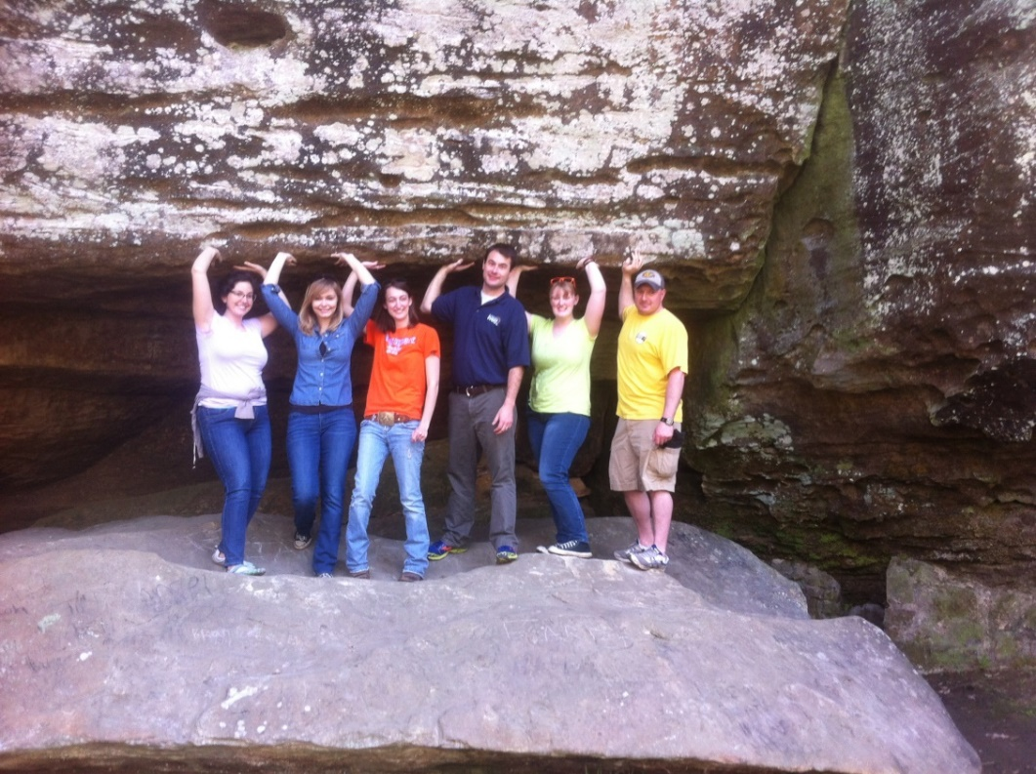**

ENS at Shawnee National Forest, 2014.

**Why do I have to write a proposal instead of just getting started?**

The proposal should convince your research committee that

* the research is important and the results will be significant;
* the research is doable in terms of funding, equipment, personnel, data, time, etc.;
* you understand the limits to the breadth and usefulness of the research;
* the research will be done in accordance with UIS policies (e.g., Institutional Committee for the Care and Use of Animals; Institutional Review Board);
* and you are capable of doing the research and presenting the results in a professional, competent, ethical, and efficient manner

**Research Advisor**

When you were admitted into the graduate program, an academic advisor was assigned to you. If you plan to complete a Thesis or Graduate Project, you will need to identify a research advisor. To do so, talk with ENS faculty to find someone with expertise in the area you wish to pursue for your research. It must be a mutually agreeable decision.

**Finding a Research Topic**  
Although your research advisor might have some ideas, remember that you are the one who will be doing the work. Therefore, it should be a topic that interests you – *a lot*. The UIS library maintains a list of past theses and graduate projects (<http://www.uis.edu/archives/theses/ens.htm>). This list might provide you with some good ideas, but keep in mind that not all of these would be appropriate topics today. The composition of the faculty has changed, so expertise has changed over time. Additionally, because environmental science is still a young discipline, research that was considered groundbreaking a few decades ago might now be routine and mundane. Here are a few thoughts on selecting a topic:

* Read everything (especially review papers) in your area of interest, and by key researchers in your field. Hunt for unanswered questions, competing theories, and suggested research ideas.
* Talk with everyone, both within and outside your own field. Meet with ENS faculty and talk with other grad students.
* Find ways to extend previous research, for example by applying existing methods to new areas or situations. (This is particularly common at the master’s level.)
* Attend classes, lectures, and other special events that may spark ideas. Attend professional conferences and meetings.
* If you are interested in a particular study area, go there and talk with locals to learn about local issues.
* Think about what information is needed for effective management of a particular environmental system, species, or landscape of interest to you.
* Some topics may require grant funding or extra time, which means you need to start as soon as you begin your degree.
* Listen to or read major media sources (such as the NY Times, The Economist, Bloomsberg Businessweek, NPR, BBC, etc.) to determine the emerging environmental issues which will be part of future policy discussions.
* Plan your research around a needed product (map, model, technique, protocol, policy recommendation, etc.). Talk with potential users (policy makers, government agencies, university extension, non-profit agencies, citizen groups, farmers, etc.) to determine specific needs.

**Writing the Proposal**

Work with your research advisor to create a proposal following his/her suggestions. (The above list contains only some general guidelines, and will need to be altered for some topics.) Only after you have your research advisor's approval should you send the proposal to your research committee. The committee needs to have the proposal at least one week before your scheduled defense. Contact your committee in advance because in some situations they may need more time.

**Research Committee**

In addition to your research advisor, your research committee will contain a second faculty member from ENS (Department Representative) and a faculty member from another UIS department (Dean's Representative). In some cases, a committee will have a fourth member (Student's Representative), who can be outside of UIS, but must hold at least a master's degree. All committee members must be mutually agreed upon by both the student and the research advisor.

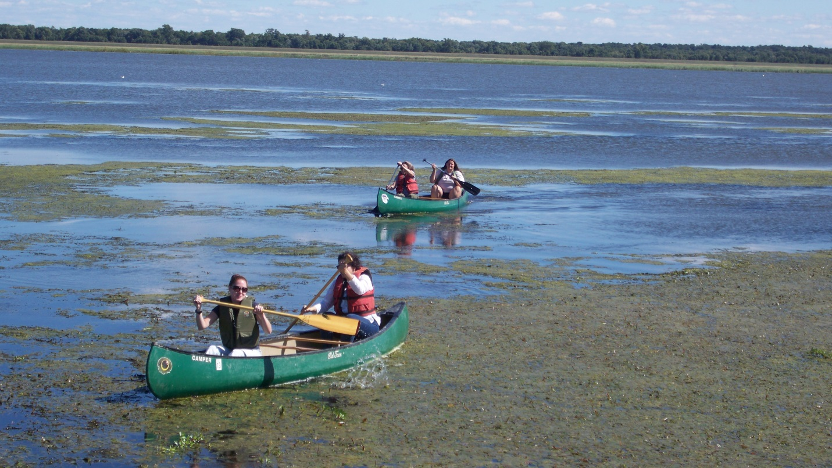

ENS at Emiquon, 2013.

**Enrolling in Thesis / Graduate Project**

Students completing a Thesis or Graduate Project must enroll in a total of four credit hours of ENS 510 Thesis or ENS 520 Graduate Project. However, it is not necessary for students to enroll in four credit hours in a single semester; they can be accrued in smaller increments. Once a student starts to enroll in either ENS 510/520, she/he must continue to enroll in ENS 510/520 for each fall and spring until the four hours are accumulated. If the Thesis or Graduate Project has not been completed by the time the four hours are accumulated, the student must then enroll in either ENS 511 Thesis Continuing Enrollment or ENS 529 Graduate Project Continuing Enrollment for each fall and spring until the Thesis or Graduate Project is finished. ENS 511 and 529 are zero credit hours, but one billable tuition hour.

**Proposal Defense**

The first part of the proposal defenses must be open to the public. So, in addition to finding a time agreeable to your entire committee, the defense must be during normal working hours (i.e., not evenings, weekends, holidays). During the public portion, you will give a 20 minute presentation on your proposed research. Afterwards, the public audience may ask questions. Once the public audience is excused from the room, the research committee will then ask questions about the proposal. This segment can frequently take an hour or more. Immediately after these questions the research committee with meet privately to discuss the performance. The committee will determine whether you pass or fail, and will provide both general and specific feedback on what the next steps should be. (Even if you pass, anticipate some changes being made.) Schedule the defense for two hours in length, even though it is possible not all time will be needed. All of your committee members must approve of your proposal and sign the approval sheet (Appendix III).

**Thesis / Graduate Project Defense**

After successfully completing the proposal defense, you will then spend several months doing the research and then writing the Thesis or Graduate Project. The steps for the Thesis/Graduate Project defense mirror those for the proposal defense.

**Wrapping it Up**

Once you have made all changes requested by your committee, you will need to gather signatures from your committee for the master’s closure form. There are a few other steps. Be sure you have completed the online graduation application. Email a copy of your final Thesis or Graduate Project to the Department chair for archiving. Print and bind a paper copy for the UIS library; take to the Department chair.

**Capstone Closure**

**Overview**

The Capstone Closure (ENS 550) gives ENS students a closure option that provides the opportunity to apply, in a professional setting, the fundamentals taught in ENS courses via an internship experience. ENS faculty thinks that internships create valuable, practical experiences, and that students should earn academic credit for these experiences. Therefore, ENS 550 formally integrates a UIS-approved closure option with professional opportunities. ENS 550 is a four-hour course that provides an alternative to the traditional thesis or project.

By the end of the Capstone Closure, students must demonstrate

* a command of knowledge of important and current literature related to the objectives set forth in the student's internship plan (see below),
* the ability to identify a research question, applied activity, or issue that leads to a major internship commitment,
* mastery of appropriate methodology necessary to conduct internship work,
* an understanding of the organization, process, and institutional environment of the interning entity,
* proficiency and effectiveness in written and oral communication, and
* professionalism in both academic and work environments.

**Internship Portion**

In addition to a limited amount of more traditional coursework activities (readings, online discussions), the Capstone Course has a significant internship requirement with the following major aspects:

* submission and approval of internship plan
* 240 hours of internship experience
* progress reports
* final report and presentation

**Internship Guidelines**

The internship component of the Capstone Closure provides an integrative experience in which students complement their coursework with real-world experience. The following standards are established to ensure consistency in the work experience, workload, and performance of ENS students in the internships.

* **Timing of Internship:** Because application of coursework to the internship experience is a major goal/outcome for the capstone, students will only be eligible to register for the Capstone Closure after successful completion of a minimum of 28 hours of coursework toward their degree requirements. These 28 hours must include the ENS common core courses: ENS 551, ENS 552, and ENS 553.
* **Internship Workload:** The internship requires a minimum of 240 hours of professional experience. For the anticipated immersive experience, twelve 20-hour weeks or eight 30-hour weeks are suggested, but this can be modified to meet the needs and abilities of the host organization. The internship normally should be completed within the single semester for which ENS 550 is taken. Contact the Capstone Closure instructor if you would like to start the internship before the semester starts.
* **Location of Internship:** The internship may be undertaken at the place of regular employment of the student, including GPSI positions, if an appropriate internship plan can be developed that meets the purpose of the closure option. Students may also seek volunteer or other activities, provided that there is no conflict of interest and that the internship plan is approved by the ENS faculty.
* **Internship Plan:** An Internship Plan must be executed by the student, the host, and the instructor before the internship begins. If you are not employed at your place of internship, we will also need to complete a signed Affiliation Agreement with the host institution. (That agreement is a legal document that will be sent to the internship supervisor after approval of the Internship Plan. Contact the Department chair for information regarding this agreement.) Instructor permission to enroll in ENS 550 will require each student submit and have approved a detailed Internship Plan. The Internship Plan should explain student learning goals and objectives, list in detail the assigned tasks, and outline the opportunities for the student to exercise individual responsibility. The completion of the Plan should focus not simply on having a job, but rather on the learning experiences gained through the internship as well as the opportunities to integrate such experience with prior ENS coursework. (Therefore, students must specify how their proposed internship relates to the degree objectives, as listed in the UIS catalog, and the skills/knowledge acquired during coursework toward the MA.) The Internship Plan should be considered as a communication device that ensures all parties understand what is expected of them. See the next section of this handbook for a detailed description of what should be in the Internship Plan.
* **Progress Reports:** Students will submit to the instructor periodic progress reports. A progress report is due after 50, 100, 150, and 200 hours. These reports should be brief (2-3 pages) and communicate to the ENS 550 instructor any progress and/or problems. The progress report should not be a laundry list of activities performed but instead provides an opportunity for periodic reflection on the internship by the student. It should selectively address those components of the Internship Plan that have been completed in relation to the student learning goals and relevant coursework, and serve as a foundation for the capstone internship final report.
* **Capstone Internship Final Report and Presentation:** The professional internship provides the student with an integrative experience to which they can apply the knowledge and techniques learned from coursework. This experience should be summarized in the final report and presentation. The final report should have a copy of the supervisor’s evaluation (Appendix IV) amended at the end. In addition to the written report, the student will prepare and deliver a professional presentation that discusses and illustrates the major components included in the written report. Because the Capstone Closure is taught online, students will, at minimum, be able to make the presentation online. The particular program used, and any possible alternate venues, will be up to the course instructor. The internship report and presentation must include a discussion of the following:
  + Description of the host organization
  + Discussion of learning objectives, review of literature related to such objectives, and evaluation of whether they were achieved
  + Discussion of the major work conducted and how this work related to learning objectives
  + Examples of work products
  + Critical analysis of the institution, methods, and processes used to conduct work and any final work products in relation to relevant concepts and approaches from the student’s coursework

**Changing from Thesis/Graduate Project to Capstone Closure**

Students who initially begin a Thesis or Graduate Project, but want to switch to the Capstone Closure option, are not subject to the UIS continuous enrollment policy for closure exercises. Therefore, if you have sat out a few semesters, with only your closure remaining, by taking the four-hour Capstone Closure, you will be considered compliant with the University's continual enrollment policy. Previously-taken hours toward a Thesis or Graduate Project cannot count toward the Capstone Course; ENS 550 is only available as a four-credit course.

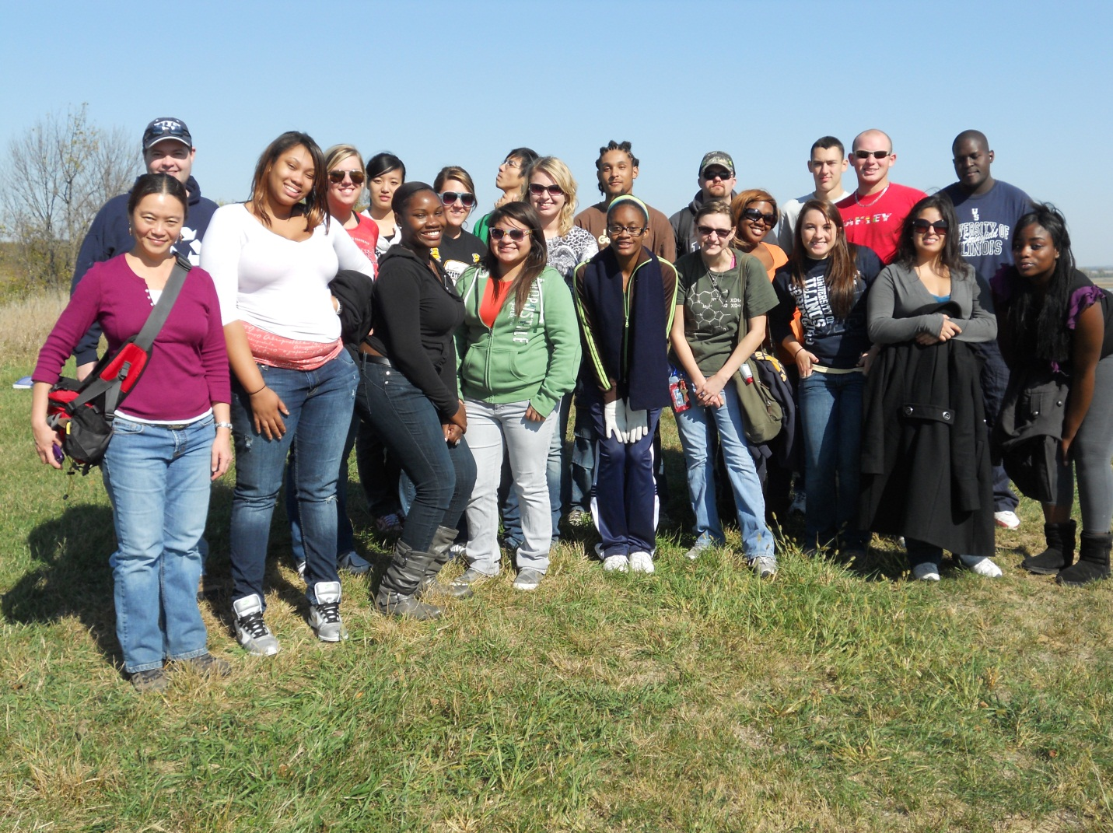

ENS at Emiquon, 2011.

**Internship Plan**

The Internship Plan must have the following sections:

**I. Parties**

List the names and contact information (mailing address, telephone, and email) of the instructor, student, host organization, and host supervisor. Provide the primary location of the student’s work.

**II. Host Supervisor Responsibilities**

The responsibilities of the host supervisor should be explicitly outlined. In general, the host supervisor needs to agree to extend an opportunity for the student to experience the areas of operation as stated in learning goals and objectives section, assist the student in identifying duties that can be constructed to best meet the student’s goals, coordinate the student’s activities, provide the direction and materials to satisfactorily complete the internship, and complete an evaluation of the student at the end of the internship experience.

**III. Instructor Responsibilities** [Just copy the text for this section.]

The ENS 550 instructor will determine if the Internship Plan is acceptable. During the internship, the instructor will oversee the student’s progress and contribute, as necessary and appropriate, to fulfillment of the student’s learning goals and objectives. Upon completion of the internship experience, the instructor will determine the adequacy of the student’s written report and oral presentation. The instructor also will set the due dates for these materials in a manner that allows time for grading before the end of the semester.

**IV. Student Learning Goals and Objectives**

Provide detailed learning goals and objectives for the work experience that relate to concepts or methods learned in academic coursework. This is not a list of your tasks; that goes in section V. A learning goal is a broad, purpose-based statement. An objective is the specific action/product that is intended to accomplish the goal. Although goals may be difficult to measure, objectives are more concrete. Make specific reference to your degree objectives and skills/knowledge learned in your coursework.

**V. Student Duties and Responsibilities**

Provide a detailed list of the tasks, duties and responsibilities that the student will perform during the work experience.

**VI. Timeline**

Provide a work schedule and due dates for progress reports.

**VII. Additional Points of Clarification**

Provide any other items relevant to the completion of the internship experience. This may include potential conflicts of interest or any potential impediments. Mention whether your position is paid or volunteer. (If the position is unpaid, email the information in Part I to the department chair as soon as possible. We will need to create an affiliation agreement with your host organization, and in some cases that can take a couple months. No hours worked can count toward your Capstone until that affiliation agreement is fully executed.)

**VIII. Approval**

Include signature lines, with date, for student, instructor, and host supervisor.

Before you sign the Internship Plan, email a well-written draft to the Capstone Closure instructor who may ask you for one or more rounds of edits. Once the instructor has approved the contents, sign, get your supervisor’s signature, and send to the instructor.

Example internship plans can be viewed here: <https://uofi.box.com/s/5s6ngt6wy9t5ft94nc23xtgvw5x9622g>

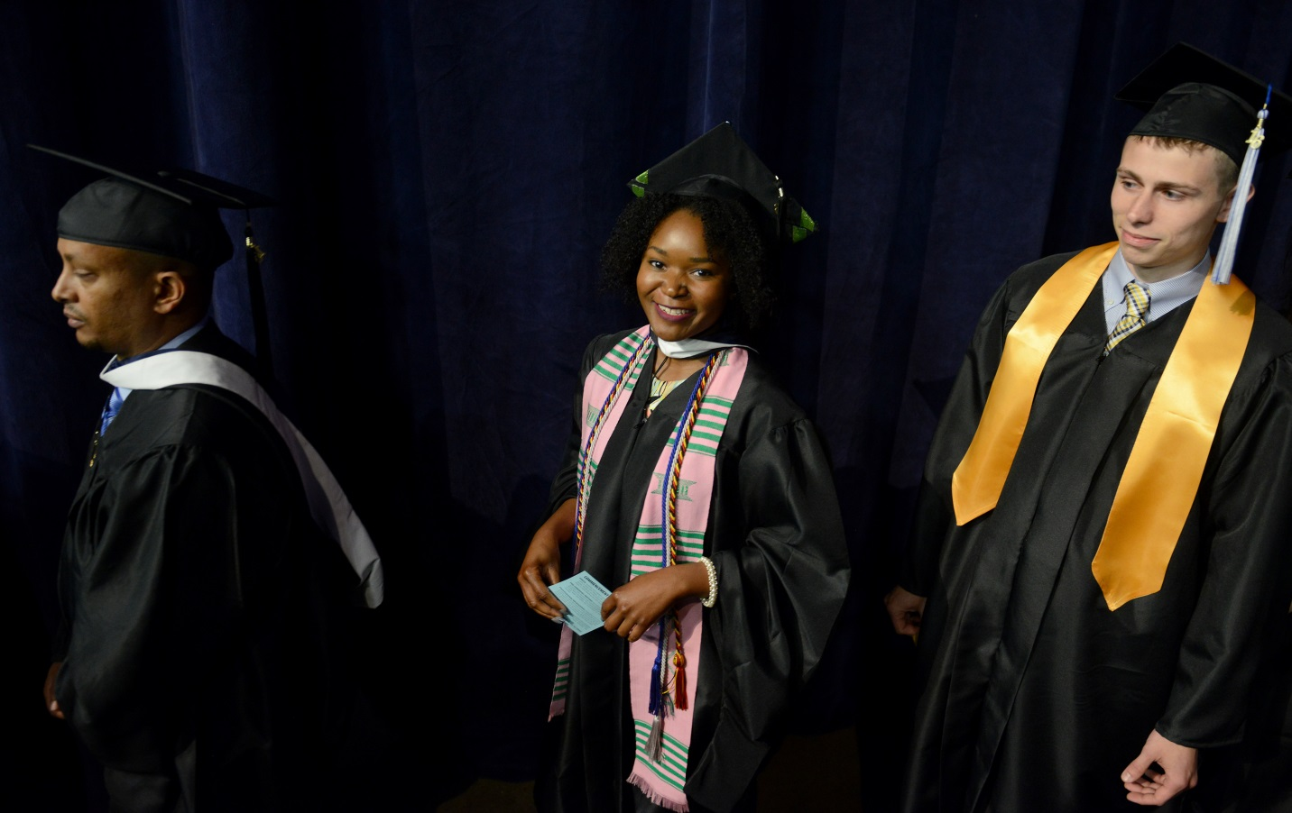

ENS at Commencement, 2016.

### Master’s Degree Limitations

University and Department policies impose specific limitations on students' work toward their master's degree:

Transfer Credit

Courses taken at other institutions can sometimes be counted toward your degree at UIS. Eligible courses must be taken after completion of a bachelor's degree, but cannot have been used toward the requirements for any other degree. The course must be at the 400-level or higher, with a grade of B or better, be taken within five years of beginning courses in the ENS grad program, and be approved by ENS faculty as appropriate for your particular Education Plan.

Time Limit

All coursework, including closure hours, must be completed within six years. There are a few exceptions, such as filing for a one-semester leave of absence or returning to complete your closure option after completing all coursework. Talk about your specific situation with your advisor or the department chair.

GPA

A cumulative GPA of 3.00/4.00 or better is required in order to graduate. Up to 4 hours of C work can be accepted only if there are a corresponding number of hours of A work to offset and an approved Student Petition is on file with the University. Grades below C may not be counted toward a graduate degree.

Coursework Grade

Regular courses must be taken for a letter grade. Closure hours, independent study, and internship may be taken Credit / No Credit.

Continuous Enrollment in Closure Hour

Once students begin enrolling in closure hours, she/he must continue to sign up for closure hours every spring and fall until graduation. After enrollment in four hours of thesis or graduate project, students must then sign up for a one-tuition-hour, zero-credit-hour of "Continuing Enrollment". Students who miss registering for a semester will be back-charged before they can graduate.

Incompletes

Receipt of a grade of Incomplete is never automatic, and such grades are given solely at the discretion of the instructor. Students requesting an incomplete should contact the instructor as soon as a problem is identified. The student and instructor will then work out an agreement on the work to be submitted and deadlines for the work. Instructors are never required to grant an incomplete or to accept any late work.

**ADVISING INFORMATION SHEET (Revised June 2022)**

**DEPARTMENT OF ENVIRONMENTAL STUDIES**

**MASTER OF SCIENCE IN ENVIRONMENTAL SCIENCE**

**REQUIRED COMMON CORE COURSES: 12 credit hours**

ENS 551 Environmental Natural Sciences (4 Hrs)

ENS 552 Environmental Social Sciences and the Humanities (4 Hrs)

ENS 553 Research Methods in Environmental Studies (4 Hrs)

|  |
| --- |
| **ENVIRONMENTAL PLANNING AND MANAGEMENT CONCENTRATION**  **Required Concentration Core: 12 credit hours**  ENS 404 Fundamentals of Geographic Information Systems **or**  ENS 503 Advanced GIS Applications (4 Hrs)  ENS 403 Transportation: Problems and Planning Procedures **or**  ENS 501 Land Use and Environmental Planning (4 Hrs)  ENS 587 Natural Resources Policy and Administration (4 Hrs)  **Concentration Electives: 12 credit hours**  Electives should be selected in consultation with academic advisor before enrollment.  **Required Closure Course:\* 4 credit hours**  ENS 5l0 Thesis (4 Hrs) **or** ENS 520 Graduate Project (4 Hrs) **or** ENS 550 Capstone |
| **SUSTAINABLE DEVELOPMENT AND POLICY CONCENTRATION**  **Required Concentration Core: 12 credit hours**  ENS 571 Sustainable Development (4 Hrs)  ENS 581 Environmental Policy and Analysis (4 Hrs)  ENS 587 Natural Resources Policy and Administration (4 Hrs)  **Concentration Electives: 12 credit hours**  Electives should be selected in consultation with academic advisor before enrollment.  **Required Closure Course:\* 4 credit hours**  ENS 5l0 Thesis (4 Hrs) **or** ENS 520 Graduate Project (4 Hrs) **or** ENS 550 Capstone |
| **GENERAL ENVIRONMENTAL SCIENCES CONCENTRATION**  **Concentration Electives: 24 credit hours**  Electives should be selected in consultation with academic advisor before enrollment.  **Required Closure Course:\* 4 credits**  ENS 5l0 Thesis: (4 Hrs) **or** ENS 520 Graduate Project (4 Hrs) |
|  |

**\* Note on Closure Options:** Students in the GES concentration must complete a thesis or graduate project. You will need to develop a thesis/project proposal, form a committee, and defend your proposal before beginning data collection or work on your project/thesis. After you have completed your draft thesis/project write-up, you will need to schedule and pass a thesis/project defense in order to graduate. Contact your faculty research supervisor to discuss this process. Students in the SDP and EPM can complete a thesis/project or they have the option to take ENS 550 and complete a 240-hour professional capstone internship. Capstone proposals (which describe the internship site, duties, and learning goals) are due the semester before you plan to enroll in ENS 550. Students can use a GPSI position or their current job (provided that projects can be identified that relate to the degree) for the capstone internship. Contact the capstone instructor for details about this process and/or to discuss your internship options. **Additional Notes:** MS Environmental Planning & Management and Sustainable Development & Policy students cannot count both ENS 530 Internship and ENS 550 Capstone Course toward degree requirements. Students cannot count ENS 425 Ecological Issues toward degree requirements.

**GRADUATE CERTIFICATE IN GEOGRAPHIC INFORMATION SYSTEMS**

**REQUIRED COURSES: 12 credit hours**

ENS 404 Fundamentals of Geographic Information Systems (4 Hrs.)

ENS 405 Fundamentals of Remote Sensing (4 Hrs.)

ENS 503 Advanced GIS Applications (4 Hrs.)

Students who enter the program having already taken ENS 404 or ENS 405 (or their equivalents) may petition to use ENS 403 Transportation: Problems and Planning Procedures or ENS 501 Land Use and Environmental Planning toward the certificate.Courses may be taken online or on-campus.

UIS logo

Department of Environmental Studies

One University Plaza, PAC 309

Springfield, IL 62703-5407

**EDUCATIONAL PLAN FOR**

**DEGREE CANDIDATES IN ENVIRONMENTAL STUDIES**

The Educational Plan is designed to accomplish two major objectives for students: It is an occasion for making the process of education self-conscious, so that the area of concentration may guide learning throughout the student's time at UIS. It is also a way of encouraging continuity in the educational experience. Finally, the Education Plan assists the department in the scheduling of future courses and anticipating potential bottlenecks.

PROCEDURES

Students are encouraged to complete the Educational Plan before enrolling in their first ENS class; but it must be completed within the first three weeks of starting classes in the department. After discussing with his or her adviser the Area of Concentration, a student must complete page 2. The student, adviser, and chair will then sign the completed portion of the plan. If the student opts to complete a thesis or project proposal, the research committee will complete a Proposal Defense form, which will be appended to this Education Plan.

When there is a major change in the student's intention – a change of Area of Concentration, or an important shift in the direction of the original Educational Plan – a new plan should be developed and signed.

**STUDENT:  ADVISOR: **

**UIN: **

**ADDRESS:  PHONE: Home **

** Work **

**EMAIL: **

**SEMESTER OF ENTRY: **

**AREA OF CONCENTRATION: **

COURSEWORK

**SEMESTER/YEAR**

**REQUIRED CORE COURSES: 12 credit hours**

Prerequisite: Ecology 

ENS 55l Environmental Natural Sciences (4 hrs.) 

ENS 552 Environmental Social Sciences and the Humanities (4 hrs.) 

ENS 553 Research Methods in Environmental Studies (4 hrs.) 

**REQUIRED CLOSURE COURSES: 4 credit hours**

ENS 5l0 Thesis **OR** ENS 520 Graduate Project **OR** ENS 550 Capstone Course 

**REQUIRED CONCENTRATION COURSES**







**CONCENTRATION ELECTIVES**

















**The signatures below indicate that the student’s Educational Plan has been approved by the Department of Environmental Studies.**

**\_\_\_\_\_\_\_\_\_\_\_\_\_\_\_\_\_\_\_\_\_\_\_\_\_\_\_\_\_\_\_\_\_\_\_\_\_\_\_\_\_\_\_\_\_\_\_\_\_\_\_\_\_\_\_\_\_ \_\_\_\_\_\_\_\_\_\_\_\_\_\_\_\_\_**

**Student Date**

**\_\_\_\_\_\_\_\_\_\_\_\_\_\_\_\_\_\_\_\_\_\_\_\_\_\_\_\_\_\_\_\_\_\_\_\_\_\_\_\_\_\_\_\_\_\_\_\_\_\_\_\_\_\_\_\_\_ \_\_\_\_\_\_\_\_\_\_\_\_\_\_\_\_\_**

**Adviser Date**

**\_\_\_\_\_\_\_\_\_\_\_\_\_\_\_\_\_\_\_\_\_\_\_\_\_\_\_\_\_\_\_\_\_\_\_\_\_\_\_\_\_\_\_\_\_\_\_\_\_\_\_\_\_\_\_\_\_ \_\_\_\_\_\_\_\_\_\_\_\_\_\_\_\_\_\_**

**Chair Date**

**THESIS OR GRADUATE PROJECT PROPOSAL**

**Student:** Click or tap here to enter text.

**Thesis/Graduate Project Title:**

Click or tap here to enter text.

**Approved by Graduate Committee:**

**\_\_\_\_\_\_\_\_\_\_\_\_\_\_\_\_\_\_\_\_\_\_\_\_\_\_\_\_\_\_\_\_\_\_ \_\_\_\_\_\_\_\_\_\_**

**Thesis or Graduate Project Date**

**Committee Chair**

**\_\_\_\_\_\_\_\_\_\_\_\_\_\_\_\_\_\_\_\_\_\_\_\_\_\_\_\_\_\_\_\_\_\_ \_\_\_\_\_\_\_\_\_\_**

**Department Representative Date**

**\_\_\_\_\_\_\_\_\_\_\_\_\_\_\_\_\_\_\_\_\_\_\_\_\_\_\_\_\_\_\_\_\_\_ \_\_\_\_\_\_\_\_\_\_**

**Dean's Choice Date**

**\_\_\_\_\_\_\_\_\_\_\_\_\_\_\_\_\_\_\_\_\_\_\_\_\_\_\_\_\_\_\_\_\_\_ \_\_\_\_\_\_\_\_\_\_**

**Student's Choice Date**

**Internship Evaluation:** The student’s primary supervisor should complete this evaluation and discuss the responses with the student. Because the internship is a learning experience, the supervisor should not hesitate to point out areas of weakness as well as those areas in which the student excels.

Student Name: \_\_\_\_\_\_\_\_\_\_\_\_\_\_\_\_\_\_\_\_\_\_\_\_\_\_\_\_\_\_\_ Semester of Internship: \_\_\_\_\_\_\_\_\_\_\_\_\_\_

Host Organization Name: \_\_\_\_\_\_\_\_\_\_\_\_\_\_\_\_\_\_\_\_\_\_\_\_\_\_\_\_\_\_\_\_\_\_\_\_\_\_\_\_\_\_\_\_\_\_\_\_\_\_\_\_\_\_\_\_\_\_\_\_\_ Supervisor Title and Name: \_\_\_\_\_\_\_\_\_\_\_\_\_\_\_\_\_\_\_\_\_\_\_\_\_\_\_\_\_\_\_\_\_\_\_\_\_\_\_\_\_\_\_\_\_\_\_\_\_\_\_\_\_\_\_\_\_\_\_\_\_\_

|  |  |  |  |  |
| --- | --- | --- | --- | --- |
| **Category** | **Poor** | **Fair** | **Good** | **Excellent** |
| Attendance and punctuality |  |  |  |  |
| Productivity (volume and promptness) |  |  |  |  |
| Quality of work (accuracy, completeness) |  |  |  |  |
| Initiative (self-starter, resourceful) |  |  |  |  |
| Dependability (thorough, organized) |  |  |  |  |
| Attitude (enthusiasm, professionalism) |  |  |  |  |
| Interpersonal relations (cooperative, respectful) |  |  |  |  |
| Ability to learn (comprehension of new concepts) |  |  |  |  |
| Use of academic training (applies education to work) |  |  |  |  |
| Communication skills (written and oral) |  |  |  |  |
| Judgment (decision-making skills) |  |  |  |  |
| Overall performance |  |  |  |  |

Please address the following areas (attach additional sheets if necessary):

1. Areas where student excels:

2. Areas where student need improvement:

3. Additional comments or suggestions for the student:

|  |  |  |
| --- | --- | --- |
| Signatures | | |
| Supervisor: | \_\_\_\_\_\_\_\_\_\_\_\_\_\_\_\_\_\_\_\_\_\_\_\_\_\_\_\_\_\_\_\_\_\_\_\_\_\_\_\_\_\_\_\_\_ | Date: \_\_\_\_\_\_\_\_\_\_\_\_\_\_\_\_\_\_ |
| Student: | \_\_\_\_\_\_\_\_\_\_\_\_\_\_\_\_\_\_\_\_\_\_\_\_\_\_\_\_\_\_\_\_\_\_\_\_\_\_\_\_\_\_\_\_\_ | Date: \_\_\_\_\_\_\_\_\_\_\_\_\_\_\_\_\_\_ |

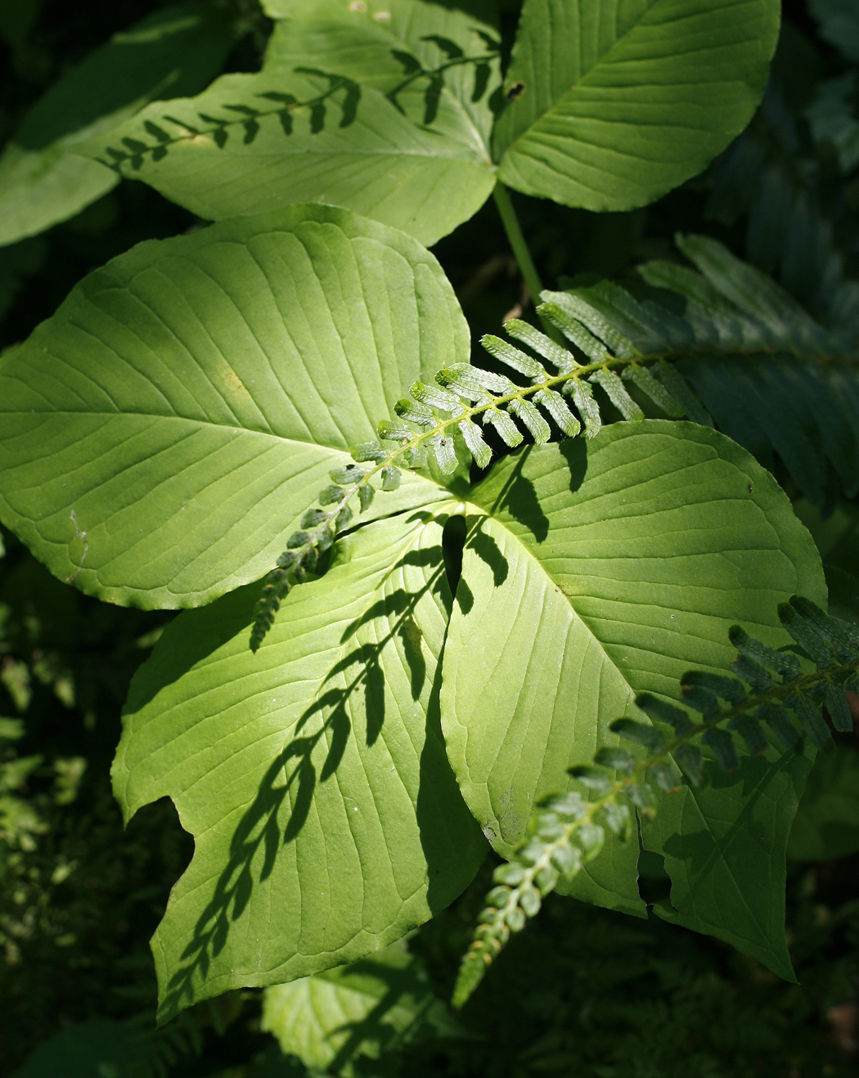

Photo by former ENS student Chris Young, 2010.