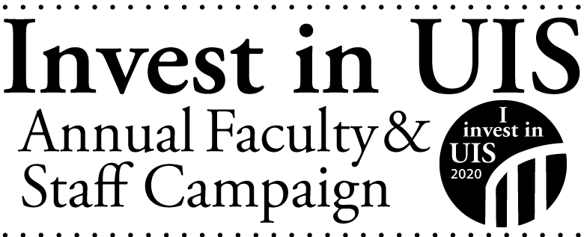

Review of FY2021
Here are some facts about the 2020-2021 Annual Faculty and Staff Campaign:

- 393 employees made 609 gifts*, totaling $547,057.
In FY20, 353 employees made 566 gifts, totaling $132,118.

- Percentage of employees who gave: 50.64%
In FY20, the giving rate was 43.37% and in FY19 it was 51.24%

- Percentage of employees who gave, by employee type:
  - 35.18% of civil service employees (28.83% in FY20)
  - 52.73% of faculty employees (47.17% in FY20)
  - 70.42% of academic professional employees (61.11% in FY20)

- Top funds where employees gave:
  - NPR Illinois/WUIS (109 donors)
  - UIS Cares Food Pantry (49 donors)
  - Illinois Innocence Project (41 donors)
  - Friends of Brookens Library (39 donors)
  - UIS Fund (31 donors)
  - Child Care Center (25 donors)
  - Astronomy (18 donors)
  - College of Business and Management Scholarship (17 donors)
  - Athletics (16 donors)
  - Clarice Ford Fund (16 donors)
  - FRIENDS of UIS Performing Arts Center (16 donors)

Gifts July 1 – June 30 count as participation in the Annual Faculty and Staff Campaign. Gifts can be to any area of UIS and in any amount.

*Number of gifts is counted as a person giving at least 1 gift to a fund in the fiscal year. Multiple gifts to the same fund inflate those numbers (i.e., payroll deduction gifts). In reality, 2,530 separate donations were made to UIS by employees in FY21.

