UIS Green Projects Application
Full Project Proposal- Step 2

To complete your Full Project Proposal, download this word document and type all answers to the questions below. Save your completed word document along with any supporting documentation (excel spreadsheet of budgeted itemized items, letters of support, and so on) as new files. Supporting files in Word (.docx) format should be attached to the end of this application in order to create only one Word document. Supporting files in all other formats (pdf, excel, PP) may be submitted as separate documents.

Once completed and saved to your device, return to the Green Projects website at http://www.uis.edu/greenprojects/get-involved/

Click the hyperlink titled, “Submit your completed UIS Green Project Proposal”
This can be found under Step 2 of the “Submit a Green Project Proposal” section.

You will be redirected to an external WebQ. Upload your completed application along with any supporting documentation by the deadline found in the “Timeline” section of the Green Projects website.

NOTE: Please do not submit this application unless you have been formally invited to do so by the UIS Green Fee Committee.

If you have any questions regarding the application or submission process, please contact us at greenprojects@uis.edu.

Project Name:
Pollinator Paradise
Contact Information:

Project Team
Name | UIS Student/Faculty/Staff & Department (or Office) | UIS Email | Phone #
Courtney Roberts | UIS Student | Crobe23@uis.edu | 8325061500

Organization/Affiliation:
Sustainability Projects Coordinator

Project Information:

Provide a brief description of the project, its goals, and the desired outcomes:

The goal of this project is to create a space for pollinators, specifically the Monarch butterflies. Springfield Illinois resides in the Monarchs migration path. With less and less natural habitat and more obstacles for these pollinators and others alike providing a sanctuary for these creatures to rest, eat, and thrive would be beneficial to our local ecosystem and to their survival as they complete one leg of their long journey.

How will this project improve sustainability at UIS?

Being able to provide a sanctuary for the Monarchs and other pollinators can ensure the success of pollination for the local flora and promote biodiversity in the area. While also providing a place for education and enrichment of outdoor space on campus.

Please indicate how this project will involve or impact students. What role will students play in the project?

Students will be able to learn about the importance of pollinators and be able to enjoy the area that is created for them. Pollinator Paradise might need initial volunteers, but it will be self-sustaining and should not need additional work outside initial implementation.

Where will the project be located? Do you need special permissions to enact the project at this site? If so, please explain and attach a letter of support to your application. If you are not sure, let us know! We can help.

This project will be located on the UIS Campus. With the help of the Grounds Staff a suitable location that is both ideal for the pollinators and acceptable for the vision the Board is trying to promote. Along 11th street is one option. Another would be behind C parking lot on the north side of campus where there is a vacant field that is not currently being used by any other club, organization or sport. I have attached a letter to the board asking for permission and for the collaboration in the appearance of the garden to help with any disagreements that may come.

Other than the project team, who will hold stake in the project? Please list other individuals, groups, or departments indirectly or directly affected by this project. This includes any funding entities (immediate, future, ongoing, etc.) and any entities that will be benefiting from this project. Communication with affected departments is encouraged ahead of time. List the names of who you spoke with and their comments.

This is a project that is outdoors and will be displayed to the public. Most everyone on campus will be exposed to its appearance and the pollinators that will frequent the garden. Students, staff, faculty, and visitors will have the opportunity to visit this garden and enjoy its native and natural beauty. One department that it does directly affect is going to be Grounds. I have written to Brian Beckerman but have yet to hear back from him. But the project was suggested by a member of grounds*. Grounds will be the entity that we would require assistance from when installing the garden initially. Thereafter Grounds would need to be aware of any care that might come with it. While none is foreseen and all of the plants are native perennials, education in knowing not to mow the area will be needed. it would also be a great opportunity for students to volunteer, either from the Green Fee Committee or from the UIS Community Garden or even those that need volunteer hours.

As stated above I have also included a letter to the board asking for their collaboration in display of the garden.

Have you applied for funding from the Student Green Fee previously? If so, for what project?

No

Scope, Schedule, and Budget verification

Do you have a plan for project implementation? Describe the key steps of the project.

With the approval of this proposal around late- November early December, help of Grounds staff to find an ideal location for the project by mid-January, approval from the Board by mid-February, place order for plants/seeds by early-March. Order arrival by mid-April and seed placement at the end of April-early May depending on the weather.

The biggest part of this project would take place in mid to late April, when the ground selected for the project will need to be prepped. This will most easily be done with the assistance of machinery with either a bobcat or something similar that Grounds can provide. Mid to late April will be ideal for 2024 since this year we are under the influence of a very wintry El Nino. To the prediction of the Farmers Almanac, winter will continue well into March.

After the ground has been turned and proper soil is exposed if following through with sowing, this will be a fairly easy task of spreading the seeds. A seed spreader has also been added to the budget.

List all budget items for which funding will be required. Include the cost for each item requested. Please be as detailed as possible, to the best of your ability. If you know where you would like to purchase materials from, please list the contact information of the retailer(s) below, along with the URL addresses to each item you will be requiring. If you need suggestions for how and where to purchase materials, please contact the Student Sustainability Projects Coordinators by email.

Here I have provided some options when it comes to purchasing of seeds for this project. I have chosen to use a company called Eden Brothers as the supplier. There are many options to buy specific species individually as well as bulbs for some flowers. I have explored their mix options that are categorized, one that is native flowers of Illinois, another is a perennial pollinator mix, and one that is Native North American wildflowers. I have also included the purchase of Milkweed because the main goal is to attract Monarch Butterflies.

 | ¼ Pound | 1 Pound
- Native North American Mix | $19.99 | $59.99
- Perennial Pollinator Mix | $28.99 | $86.99
- Illinois Wildflower Mix | $13.99 | $39.99
- Butterfly Milkweed | $186.99 | $571.99

1. https://www.edenbrothers.com/products/native_wildflower_seed_mix
2. https://www.edenbrothers.com/products/perennial-pollinator-seeds-mix
3. https://www.edenbrothers.com/products/illinois-wildflower-seed-mix
4. https://www.edenbrothers.com/products/butterfly_weed_seeds

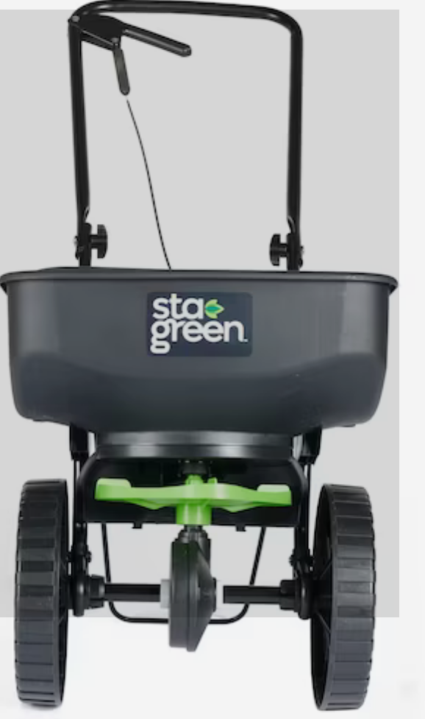 Seed spreader, $39.99. Link below
https://www.lowes.com/pd/Scotts/5013973807?cm_mmc=shp-_-c-_-prd-_-lwn-_-ggl-_-LIA_LWN_107_Fertilizer-_-5013973807-_-local-_-0-_-0&gad_source=1&gclid=CjwKCAiAu9yqBhBmEiwAHTx5py_5foq_xxnDN6V7W03lB2bngIW8DX20uMmSF0kS7mu9w8ME0G35_hoCSmUQAvD_BwE&gclsrc=aw.ds

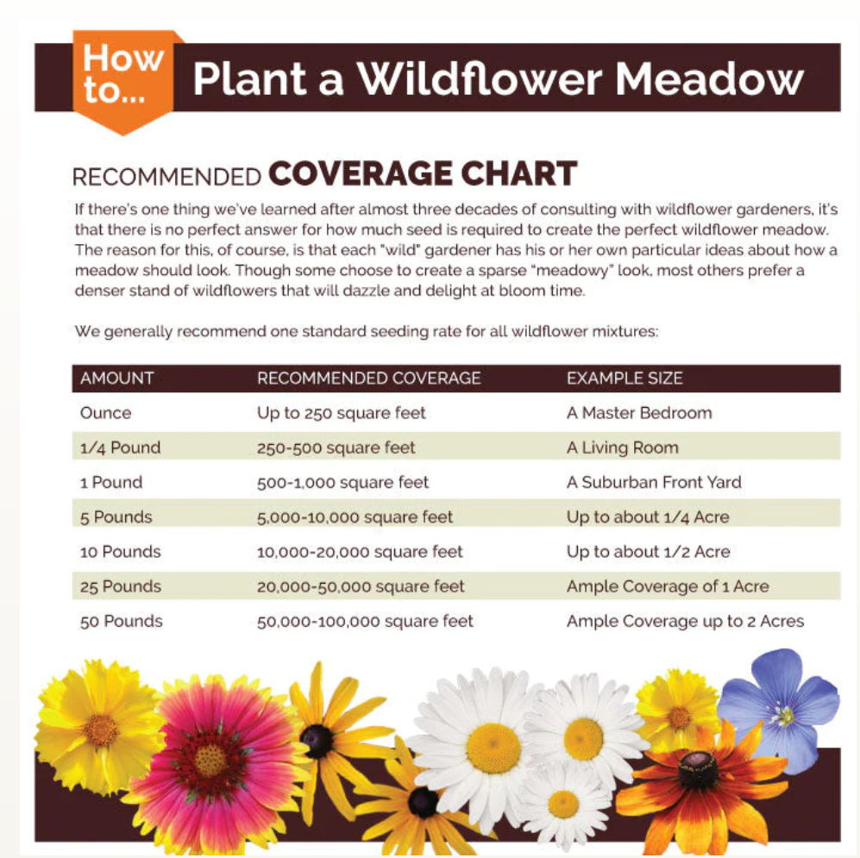
- Other costs may include labor Grounds

Will this project require ongoing funding? Do you have a plan for supporting the project in order to cover replacement, operation, or renewal costs?

Because all of these native plants and flowers are perennial they do not need to be repurchased. If the seeds are bought in a larger quantity, any coverage needs to be supplemented the remaining seeds from initial installment should be sufficient for a couple of years. Depending on where the placement of this garden is initial watering of the seeds will need to be addressed. Grounds does have a Kubota with a water tank.

Every project must be publicized! Where would you like to see information about this project reported?

UIS website and UIS instagram

