UIS Green Projects Application
Full Project Proposal- Step 2

Project Name: Flushing Away Being Unsustainable

Contact Information: Ellie Shonkwiler ers5@uis.edu, Anna Schurz aschu26@uis.edu

Project Team
Name | UIS Student/Faculty/Staff & Department (or Office) | UIS Email | Phone #
Ellie Shonkwiler | Student | ers5@uis.edu
Anna Schurz | Student | aschu26@uis.edu
Salomé Wortman | Sustainability Projects Coordinator/Student | swort2@uis.edu
Madeline McGuire | Student | mmcgu6@uis.edu

Organization/Affiliation:

This proposal is adapted from Ellie Shonkwiler’s and Anna Schurz’s original Low Consumption Toilet project from the 22-23 funding year. Edits have been added to reflect new locations for toilets.

Project Information:

Provide a brief description of the project, its goals, and the desired outcomes:
On the UIS campus low flow toilets are in the UHB and Student Union, and this project seeks to add more. A dual flush toilet is one that uses different amounts of water depending on the need. This would save water when only flushing urine but still make sure that feces flush by having a flush with more water. A building that could benefit from this would be the Performing Arts Center (PAC). It is a high-traffic location between students going to class or the bookstore as well as people from the community attending an event. While this building would be a starting block to be more sustainable we would love to see the idea campus-wide if funding allows. The goal of this project is to lower water waste on UIS campus and be able to install dual flush toilets in a building. This will help the campus save money as well as lower the excessive water waste.
Water waste is a topic that seems to be swept under the rug but lowering how much water we waste will allow our campus to be greener. The bathroom stall would have a sign, “Brought to you but the UIS Green Fee” but it could also have a flier when it first gets installed to inform students, staff, and faculty. Furthermore, the dual-flush toilet would benefit students but also workers like faculty and staff. Being greener is the goal of the green fee committees and this is one way for us to do so. Initiating sustainable building projects is smart for us to not only be more sustainable but for us to have more modern building designs.

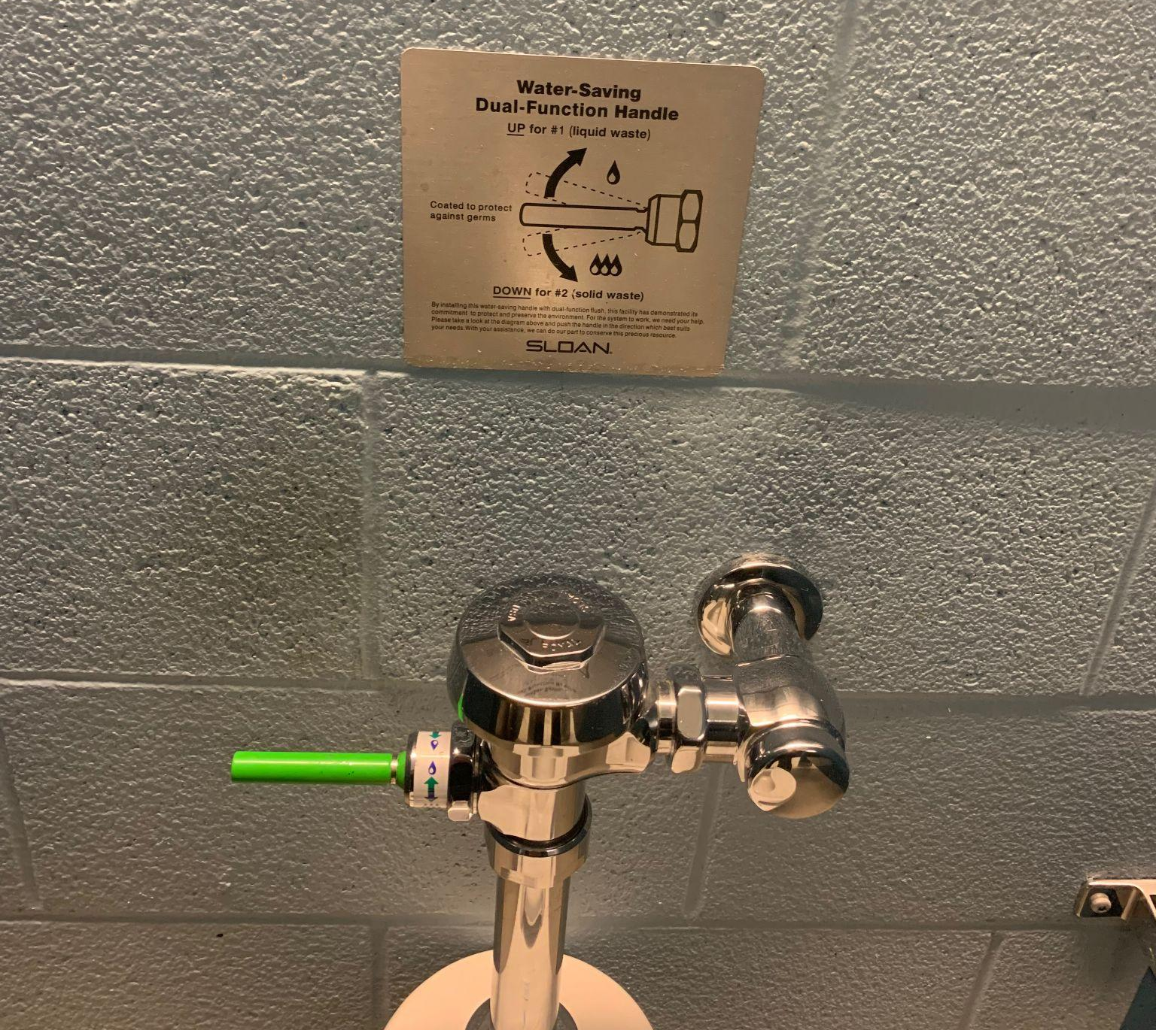

As pictured above is an example of what our signs could look like. This was taken at the GVSU indoor track facility.

How will this project improve sustainability at UIS?
Although Springfield is not plagued by droughts, the necessity for using water wisely is still important. Water is a resource that everyone needs to survive and thus we all need to take care of it. One part of the definition of sustainability is using resources in a way that doesn't deplete them or cause the natural cycle of resources to become unstable in order to ensure that future generations and the environment around us can benefit from them. Water waste happens every single day and it is not something that many people focus on. A dual-flush toilet has the ability to save half a gallon of water with each flush. This will add up over time allowing us to save water with each person who uses a toilet. Both the long-term and short-term effects are using less water. Over the long term we could make a significant impact and conserve water. Furthermore, we could have short-term and long-term effects of making students, faculty, and staff more aware of their water usage. This could help change their short-term behavior, such as using the dual flush option, but also their long-term behavior by changing some of their daily habits through creating awareness.

Please indicate how this project will involve or impact students. What role will students play in the project?
The students on campus would be involved by actively choosing to use it and participating in the dual flush system. The same would be true for the low consumption toilets, the students would be actively participating by using them. They would be affected by it by becoming more aware of their water consumption. Then students could become involved in helping conserve water by changing their daily habits. Furthermore, as previously stated, not only will students benefit but also faculty and staff since they can also use the project. Moreover, the faculty and staff can also become aware of their water-consumption and thus change some of their habits.
This project also shows students how their green fee money is used since it is something that is used on a regular basis and can be used by everyone.
The university can also use their sustainable features to attract students. It shows that they are environmentally conscious and in the case of this project, aware of their water consumption. Current and incoming students may find this important and support the university by choosing to attend it.

Where will the project be located? Do you need special permissions to enact the project at this site? If so, please explain and attach a letter of support to your application. If you are not sure, let us know! We can help.
To ensure the biggest impact on the UIS campus we believe that the toilets should be installed PAC or HSB. These buildings have high foot traffic, meaning toilet usage is also very large. Allowing for dual flush toilets in this area ensures that water will be conserved because of how many people will be using them. We would like to install as many dual flush toilets as we can in each restroom at PAC or HSB.
To order and install parts we will need assistance from facilities and services.

Other than the project team, who will hold stake in the project? Please list other individuals, groups, or departments indirectly or directly affected by this project. This includes any funding entities (immediate, future, ongoing, etc.) and any entities that will be benefiting from this project. Communication with affected departments is encouraged ahead of time. List the names of who you spoke with and their comments.

The main individuals who will be affected by this are the students, maintenance workers, UIS staff, and the public. The maintenance workers will be the ones installing this new system so they will be involved quite a bit in the beginning. Chuck Coderko was consulted about this project and the emails are attached below. Besides that, the rest of the people will be involved by using these toilets. PAC and HSB are very popular areas for all people so each person who uses them will be involved in some way.

Have you applied for funding from the Student Green Fee previously? If so, for what project?
Yes. This same project was accepted in the 2022-2023 cycle.

Scope, Schedule, and Budget verification

Do you have a plan for project implementation? Describe the key steps of the project.
This project can be implemented as soon as the funds are approved. The items will need to be bought and then they can be installed when the university (facility and maintenance) sees fit. I would advise installing the toilets on a day where there are little staff and students present, such as a Friday. We would go in increments; the toilets would not need to be installed all at the same time. It can also be done in the summer or between semesters. The implementation process should not take long as there are not several steps, and it does not depend on the season. The toilets would be installed and then we can monitor the success of the project.
In addition to the toilets, it would be helpful to have an explanation for the project so that students/faculty/staff can understand the use of the Green Fee money and be aware of the project. Adding signs to the project could be something that could be discussed in the committee and chosen to do at any time after the implementation of the project.

List all budget items for which funding will be required. Include the cost for each item requested. Please be as detailed as possible, to the best of your ability. If you know where you would like to purchase materials from, please list the contact information of the retailer(s) below, along with the URL addresses to each item you will be requiring. If you need suggestions for how and where to purchase materials, please contact the Student Sustainability Projects Coordinators by email.

For this project we would need to buy a toilet bowl and a valve in order to make a low consumption toilet. The university uses tankless toilets, and they are wall mounted. When looking at saving water it is important not to buy touchless sensor toilets since those can malfunction and end up using water or the battery runs out. When the battery runs out it will prevent things from being flushed and thus it will sit around.
When looking at the direction of the project for installing more low-consumption toilets, we would stick to the previous suppliers for the university and give them funding to buy and install more.
With the help of Charles Coderko, the associate vice chancellor of facilities and services, it is estimated to be about $275 for a low-consumption toilet. This would include $125 for the 1.6-gallon toilet bowl and $150 for the 1.6-gallon flush valve from current suppliers. Thus, depending on the budget of the Green Fee it would be possible to obtain numerous new toilets and make a significant impact on the water consumption. The current suppliers are through construction suppliers and the university buys Kohler or American Standard.

Below are different sizes of the project and the cost for installing low-consumption toilets only:
Number of Toilets | 1 | 2 | 5 | 10 | 20 | 30
Cost | $275 | $550 | $1,375 | $2,750 | $5,500 | $8,250

When going the route of the dual flush toilet, it needs to be taken into consideration that the university uses tankless toilets and that installation would need to avoid ripping open walls, etc. This being said we would have to buy a diaphragm and handle that would convert an existing low consumption toilet into one that also has the dual flush feature. We would buy the Regal 111 model diaphragm and green handle kit from Regal as well. For $60 we could convert one toilet into dual flush. In case we run into an older toilet which has a flush valve that isn’t compatible with the Regal diaphragm and handle then it would require a new flush valve. A new flush valve could be bought for $203 a piece.

Below are the costs for installing dual parts only:
Number of Toilets converted | 1 | 2 | 5 | 10 | 20 | 30
Cost | $60 | $120 | $300 | $600 | $1200 | $1800
Again if we run into any compatibility issues it would be $203 dollars per toilet. Further this table means that the toilets converted into dual flush would already by low consumption.

Below is another table in case we need to do both: convert to low consumption and dual flush.
Number of Toilets | 1 | 2 | 5 | 10 | 20 | 30
Cost | $335 | $670 | $1,675 | $3,350 | $6,700 | $10,050

This budget shows that we can make a major impact by changing a lot of toilets to low consumption and thus making a big effect on water consumption. We could also either do a pilot project for the dual flush toilets or change a lot of existing low consumption toilets into dual flush toilets and thus make a major impact in this manner.
Overall, the cost depends on how large we want to take this project, but it is feasible and can make a major impact

A big thank you to Charles Coderko for helping with the budget and feasibility of this idea. Attached is an email from Charles Coderko. He is very excited about this idea and would support implementing it.

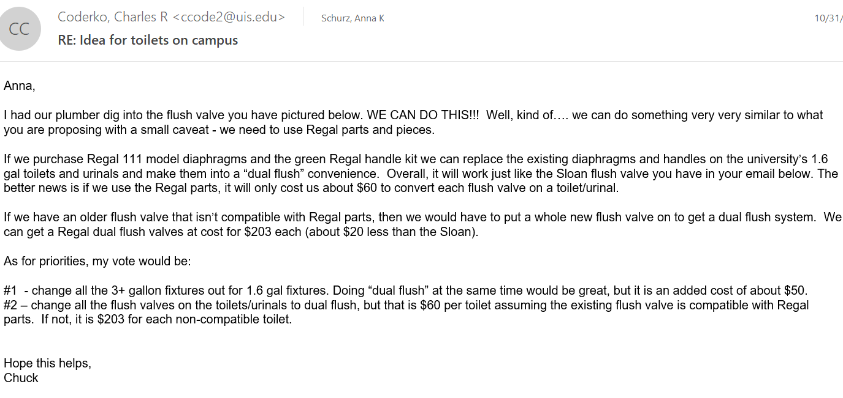

Will this project require ongoing funding? Do you have a plan for supporting the project in order to cover replacement, operation, or renewal costs?
This project does not require ongoing funding from the green fee. There is no repetitive need for money since it is a one time cost for installment. Further, if there are any needed repairs the university should cover it.

Every project must be publicized! Where would you like to see information about this project reported?
We would like to see information published on the UIS website and their social media. Awareness will help make this project successful because the more people know about it, the more people can/will use the water conserving toilets. Further it would be helpful to have flyers in the restrooms when they are installed to have information on what it does to help sustainability efforts and on how to use it. For example the dual flush handles are pulled up or down depending on the need for water. It could be considered to have a permanent sign in the restrooms or stalls in order to create awareness so more people use the feature. Further, we could consider putting information on the big screen in the union in order to make people aware of where their green fee money goes and to again, spread awareness about the water conservation efforts.
Overall, it is vital to spread information on how to use them so that they will be used. It is also important to explain why this is important to potentially attract more usage.

