Begin by opening JDXpert and clicking “Add Job” on the right side.
In the pop-up window, fill in the title of the CS or AP position. If a Civil Service position has an approved working title please also include the official SUCSS classification in parenthesis.
Start from a blank job. Do not check the Parent Job or Child Job boxes.
Select the workflow “Job Description Update (4 steps)”.
Choose approvers by clicking on the “select” word in each box (do not click on the plus (+) sign). It is possible the Supervisor and Dean/Director will be the same person in both spots. Be sure to scroll up in the drop down to Search All Employees. Select your Division Liaison for the Central HR approver (Carlene Hindert, Academic Affairs, Amy Cantrall, Student Affairs, or Madison Stone, all others).
Click “Start Workflow”.
A new window will pop up. Click the pencil & paper icon in the Job Revision Workflow box to continue.
There should be a list of tabs on the left. I have outlined the steps for each one below. You may proceed through with the buttons in the lower right and may return to a page at any time by clicking the tab on the left.
As you complete the document, please hover over the help bubbles for additional information about the field. In the form, please complete all fields. HR will complete any fields that are not accessible to you. You may save the form at any time and return to it later by double clicking on the job in your tasks.
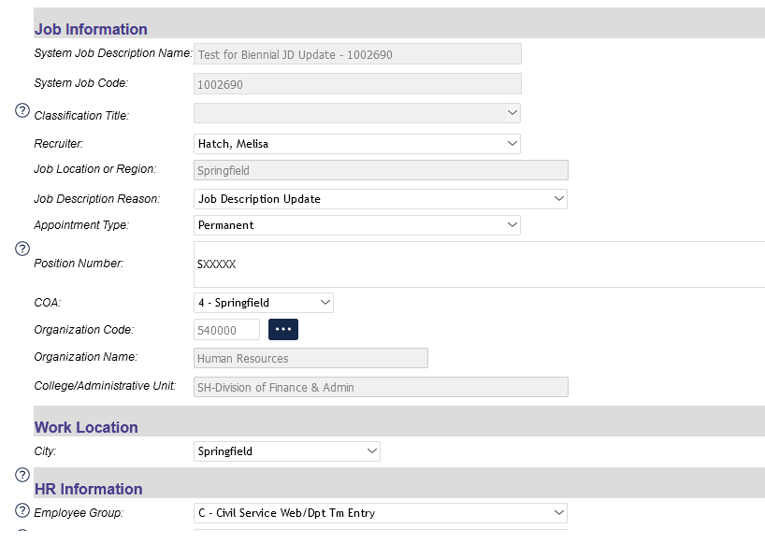
Job Information –
Select your Division Liaison for the recruiter.
Please verify via Banner, HRFE, or other means, that you enter the correct position number for the employee.
You must click on the three dots to select the appropriate organization code.
Please use the comments box to enter any information for HR, such as changes that you want to highlight or the potential need for a job audit in the future.
If you are unsure about whether this position is a Campus Security Authority, please contact your Clery Liaison: Patty Young, Michelle Vinson, Mary Umbarger, Allison Thornley, Erin Sotelo, Eileen Norris, Monica Kroft, Ann Gemberling, Eric Kuchar, or Jamie Weber. If your Clery Liaison has left the University or if you do not see one listed here for your area, please contact Lydia Schillinger (lschi4@uillinois.edu) for assistance.
Please include both the title and the name of the incumbent for the reporting line (organizational relationship).

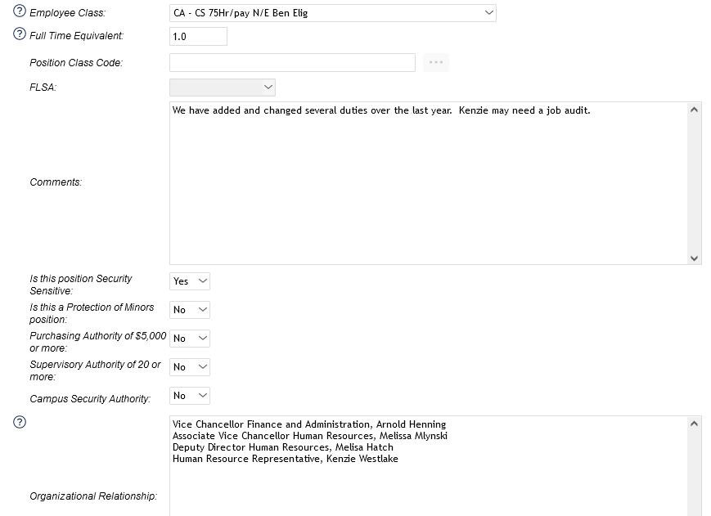

Job Summary – Please list a short summary of the job. It could include the purpose of the role, level of independence, and core responsibilities. Do not list all duties in the summary.
Duties and Responsibilities – Add row, enter duty and percentage. Add New Row until you get to 100%. PLEASE DO NOT enter knowledge, skills, or abilities in the duties section. There is a separate section to enter such things as computer skills, ability to communicate, ability to work well with diverse groups, etc. The Additional Responsibilities section is defaulted and not editable.
Qualifications – from previous JD’s. Qualifications should not change from one year to the next unless there was an approved job change. If you cannot locate a copy of a previous job description for this information, please contact your Division Liaison. For CS positions, you may also find the minimum qualifications in the classification section of the SUCSS website. Leave Specialty Factor blank unless previously included in a CS Custom Classification Hiring or Job Audit.
Knowledge Skills and Abilities are preferred but not required.
Physical Demands/Working Environment – These are important for both the employee and supervisor to prepare for requirements of the job that may affect the ability to perform the duties (i.e. appropriate clothing or footwear, lifting heavy boxes, working outside in the elements, etc.). Please select only the options that pertain to the position.
If the position requires travel, please include that in the Travel Requirements section at the bottom of the page.
Budget – Please fill in all information for the current employee that holds the position. No changes to salaries or CFOAP’s are available in this process. Please reach out to your department businessperson or HR Division Liaison if you need to discuss such changes.
Approvals and Comments – There is nothing additional for you to add here.
You may click on Preview Pane in the top right above the green line to see a preview of the job description. You may also click on the icons near the top of the preview page to save a PDF, or share with others.
When you have completed all the tabs, please click save in the bottom right.
Make necessary edits for any error messages except those that relate to HR Use Only.
Once you are satisfied with the document, please click the thumbs up icon on the left side of the green bar. Click “Approve with Errors” (those HR items).
In the new window, click “Approve Step”.
Check the box in the next window and click OK. An email will automatically send to the next approver.
Great job! Thank you for taking the time to complete this process.

