UIS Green Projects Application
Full Project Proposal- Step 2

To complete your Full Project Proposal, download this word document and type all answers to the questions below. Save your completed word document along with any supporting documentation (excel spreadsheet of budgeted itemized items, letters of support, and so on) as new files. Supporting files in Word (.docx) format should be attached to the end of this application in order to create only one Word document. Supporting files in all other formats (pdf, excel, PP) may be submitted as separate documents.

Once completed and saved to your device, return to the Green Projects website at http://www.uis.edu/greenprojects/get-involved/

Click the hyperlink titled, “Submit your completed UIS Green Project Proposal”
This can be found under Step 2 of the “Submit a Green Project Proposal” section.

You will be redirected to an external WebQ. Upload your completed application along with any supporting documentation by the deadline found in the “Timeline” section of the Green Projects website.

NOTE: Please do not submit this application unless you have been formally invited to do so by the UIS Green Fee Committee.

If you have any questions regarding the application or submission process, please contact us at greenprojects@uis.edu.

Project Name: UIS Rainwater Capture

Contact Information:

Project Team
Name | UIS Student/Faculty/Staff & Department (or Office) | UIS Email | Phone #
Lauren Conroy | ENS Student | lconr2@uis.edu | 217-917-1917
Kandi Histo | ENS Student | Khist2@uis.edu | 217-891-6237
Brian Beckerman | Grounds Superintendent | Bbeck1@uis.edu | 217-206-7202
Dr. Styles | ENS Department Chair | mstyl2@uis.edu | 217-206-8580

Organization/Affiliation: UIS

Project Information:

Provide a brief description of the project, its goals, and the desired outcomes:

I would like to have a rain barrel installed near the UIS Community Garden. I have looked at both rain barrels that connect to a gutter as well as free standing ones, and I think that a gutter-connected barrel would be the way to go at the garden. Since there are no gutters near the garden it would require the construction of a small pavilion to direct the water into this barrel. This pavilion could also serve as a place to hang out for students.
Adding a rain barrel just outside of the Community Garden fence would be beneficial to the garden. The rain barrel will capture the rain and keep it in the barrel to be used when the plants and vegetables need watered while they are growing. While this is only one rain barrel for now, it will still alleviate some water usage. Capturing rain in the rain barrel will:
  - Save water
  - Reduce erosion and flooding
  - Reduce demand on ground water
  - Improve plant growth
  - Provide a nice place for students to sit in the shade by the garden

How will this project improve sustainability at UIS?

This project could be used in teaching water conservation. I feel that everyone on campus could benefit from this project, since the less we are reliant on the municipal water the better. This could potentially lead to a larger rain catchment system for the university.

Please indicate how this project will involve or impact students. What role will students play in the project?

This project will be a direct benefit to the UIS Community Garden, and those students involved with it. It will provide a close, easy, and sustainable way to get water to the plants inside of it, as well as a nice shady place to rest! This rain barrel can also serve as a great demonstration project for a way to save water! If a professor were to want to use it for a class, it could very easily be monitored by students to see how much rain has accumulated, if there is any algae or mosquito buildup, and possibly cleaning it a couple times of year to prevent this. It could encourage students to be more hands-on and see how easy it is to save some water with a rain barrel.

Where will the project be located? Do you need special permissions to enact the project at this site? If so, please explain and attach a letter of support to your application. If you are not sure, let us know! We can help.

The project will be located at the front of the community garden. We have spoken to Brian Beckerman. The email thread has been attached.

Other than the project team, who will hold stake in the project? Please list other individuals, groups, or departments indirectly or directly affected by this project. This includes any funding entities (immediate, future, ongoing, etc.) and any entities that will be benefiting from this project. Communication with affected departments is encouraged ahead of time. List the names of who you spoke with and their comments.

The ENS department could be affected if they choose to use it for a demonstration project. Also, the grounds keepers would be affected. It would be up to them the maintain the structure.

Have you applied for funding from the Student Green Fee previously? If so, for what project?

No.

Scope, Schedule, and Budget verification

Do you have a plan for project implementation? Describe the key steps of the project.

This project is relatively simple in terms of a timeline. First, the rain barrel would need to be purchased, along with the supplies needed to construct the small lean-to pavilion to allow for more rainwater to be collected. Since we frequently have freezing temperatures throughout the months of January, February, and sometimes March, I would suggest purchasing the items in late March or early April, that way we can take advantage of all the rain we typically receive in April. After purchasing the barrel, and the materials needed for the lean-to, it should be installed right outside the fence, I think in the very front of the garden would be ideal. After installed it will simply need to be monitored for algae and mosquito buildup and cleaned a few times a year with either an undiluted vinegar, or a very dilute bleach water solution. The gutters would also need to be cleaned out a few times a year.

Purchase Materials: Late March to early April
Set-up: Once materials are purchased
Maintenance: Periodically check to make sure it is clean, with a couple deep cleanings per year, and emptying and storing before the winter months to prevent freezing.

List all budget items for which funding will be required. Include the cost for each item requested. Please be as detailed as possible, to the best of your ability. If you know where you would like to purchase materials from, please list the contact information of the retailer(s) below, along with the URL addresses to each item you will be requiring. If you need suggestions for how and where to purchase materials, please contact the Student Sustainability Projects Coordinators by email.

This project’s materials for the lean-to can all be bought at Menards in order to get the 11% rebate. Products include: One bag of concrete mix (60lb) $2.99, AC2 4x4x8 #2 Ground Contact Green Pressure Treated Timber x2 $23.96, AC2 4x4x10 #2 Ground Contact Green Pressure Treated Timber x2 $39.14, AC2 2x6x8 Ground Contact Green Pressure Treated Lumber x4 $43.92, Ac2 2x4x8 Ground Contact Green Pressure Treated Lumber x5 $36.85, 7/16 x 4 x 8 OSB x2 $47.98, Fiberglass Green Mineral Surfaced Roll Roofing 36” x 36” $29.99, Grip Fast 3” 10D Hot-Dipped Galvanized Spiral Shank Nail 1 lb. box $3.89, Grip Fast 2-½” 8D Hot-Dipped Galvanized Spiral Shank Nail 1 lb. Box $3.89, Grip Fast 1” Electro-Galvanized Roofing Nail 1 lb. Box $2.47, Spectra Metals 5” x 10’ Clay K-Style Aluminum Gutter $7.36, Spectra Metals 3” x 4” x 10’ Clay Aluminum downspout $12.56, Spectra Metals 5” White Aluminum Right Endcap $1.37, and Spectra Metals 4” Aluminum Gutter Outlet $3.35. This totals to $259.26 before tax, but also before the 11% rebate on certain items. These materials are all for the pavilion that allow for the rain barrel to capture as much water as possible. They are all from Menards, and I will attach a picture of the printed list that includes SKU numbers (bottom). These materials are not what absolutely have to be used, they are just what my dad recommended (he has been a building contractor most of his life).
As for the actual rain barrel I did the calculations to see how much rain this roof will get with average rainfall in Illinois. This roof will be 8 ft. by 8 ft., which equates to 64 sq. feet. 64 sq. feet x .56 = 35.84 gallons/inch of rain. Then, the average rainfall in Central Illinois is 35 inches per year. 35.84 x 35 = 1,254.40 gallons of water per year. Going conservatively and starting out I would just suggest getting a 150-gallon rain barrel and seeing how it works out for the first year. The best option that I found for a barrel is a simple one with a garden-hose adapter, and a mosquito proof leaf and debris strainer. The cost is $169.99 plus shipping. This can be found on Tank-Depot at https://www.tank-depot.com/productdetails.aspx?part=RC150%20GREEN. I chose this one because it seems very durable while not breaking the bank like some of the other ones. After looking at the project conducted by California State University Channel Islands, wooden barrels were greatly preferred by students and faculty. These barrels are typically smaller, only 50 gallons, and generally more expensive but may be something to consider as well! There are also options that are self-constructed that are generally much cheaper.
Overall, this project should come out to be around $500 with materials, the rain barrel, and shipping and tax included. This is of course not factoring in the labor to build the pavilion lean-to.

I used the formula to calculate gallons of water from square foot from this website: https://greywateraction.org/faq/how-much-rain-can-i-collect-from-my-roof/

Will this project require ongoing funding? Do you have a plan for supporting the project in order to cover replacement, operation, or renewal costs?

The project will require some additional funding going forward. It will mainly be for upkeep to the barrel, as well as winterizing them before it freezes, and maintaining them for potential insect problems. The barrel I linked does have a mosquito net included so it should not be an issue. The only other thing that would require additional funding is if it were decided to add another barrel in the future.

Every project must be publicized! Where would you like to see information about this project reported?
We would love to see this published on the Green Fee Committee’s website page, as well as the UIS website and journal. When students are given campus tours the tour guide could mention the community garden and that it has a rainwater capture system. We would be happy to have it published anywhere!

Here are the supply lists from Menards! If the SKU’s are too hard to read please don’t hesitate to reach out and I can make you a typed list!
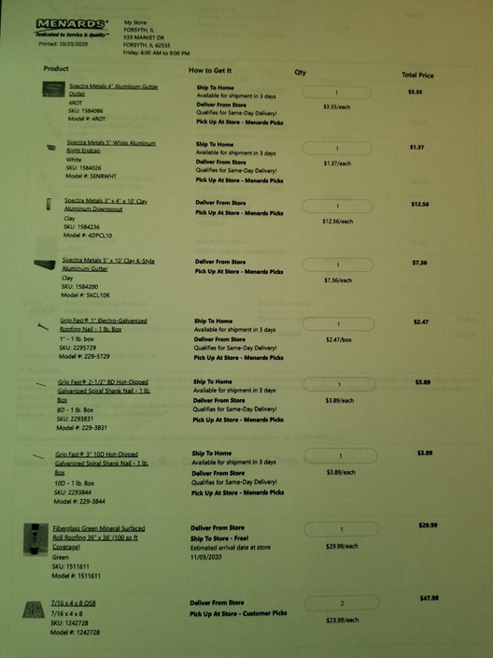
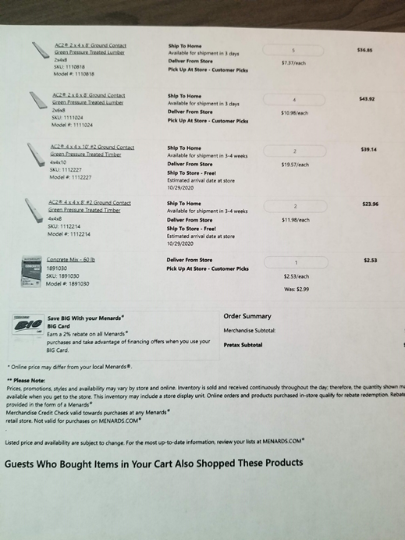

Below is a blueprint drawn up that gives a basic idea on the construction of the pavilion needed for the gutters.
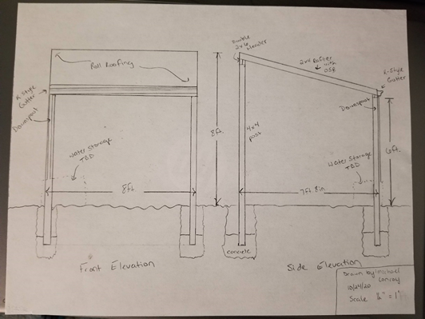
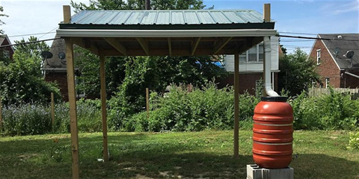
This is a basic idea of what the pavilion would look like.
Image from: https://www.brickandbeamdetroit.com/events/water-catchment-irrigation-workshop-with-detroit-future-city

