UIS Green Projects Application
Full Project Proposal- Step 2

To complete your Full Project Proposal, download this word document and type all answers to the questions below. Save your completed word document along with any supporting documentation (excel spreadsheet of budgeted itemized items, letters of support, and so on) as new files. Supporting files in Word (.docx) format should be attached to the end of this application in order to create only one Word document. Supporting files in all other formats (pdf, excel, PP) may be submitted as separate documents.

Once completed and saved to your device, return to the Green Projects website at http://www.uis.edu/greenprojects/get-involved/

Click the hyperlink titled, “Submit your completed UIS Green Project Proposal”
This can be found under Step 2 of the “Submit a Green Project Proposal” section.

You will be redirected to an external WebQ. Upload your completed application along with any supporting documentation by the deadline found in the “Timeline” section of the Green Projects website.

NOTE: Please do not submit this application unless you have been formally invited to do so by the UIS Green Fee Committee.

If you have any questions regarding the application or submission process, please contact us at greenprojects@uis.edu.

Project Name:

Contact Information:

Project Team
Name | UIS Student/Faculty/Staff & Department (or Office) | UIS Email | Phone #
Francesca Butler | Green Fee Committee | Fbutl2@uis.edu | 6185506309

Organization/Affiliation:

Green Fee Committee
UIS Recycling Educator

Project Information:

Provide a brief description of the project, its goals, and the desired outcomes:

On campus I consistently hear from students that we lack infrastructure and clear recycling directions. Moreover, I constantly see contamination in the dumpsters meant for Recycling on Campus. I feel that it is our responsibility as change makers in the realm of campus sustainability to aid in whatever way possible the students of our campus in their sustainable pursuits. Further, as a member of the U of I system, I think that we should have a high standard for such practices as Recycling. Something as simple as the labeling of Recycling bins will allow students to properly organize their waste and participate daily in the reduction of plastics/metals/papers from landfills.

How will this project improve sustainability at UIS?

This project will improve already existing sustainable infrastructure at UIS. Thus providing our students with a daily opportunity to reduce their carbon footprint. On a large scale, this improvement in recycling has the ability to reduce the carbon footprint of our campus as a whole. Not only does this aid in our individual cause, but aids in the effort to stop global climatic change. Further, adding green habits like this could improve and inspire green habits in other areas of campus (like increased usage of reusable clamshells).

Please indicate how this project will involve or impact students. What role will students play in the project?

Students will participate daily in the project by recycling. When taking out their waste for the week they will be able to clearly see where they need to put their recycling. Instead of expecting students to do more research than their schedules allow, we bring sustainability to them. Instead off assuming a base amount of knowledge we are creating a system that is more accessible than it was previously.

Where will the project be located? Do you need special permissions to enact the project at this site? If so, please explain and attach a letter of support to your application. If you are not sure, let us know! We can help.

We have already received the okay to label the bins with magnets from Chuck Coderko and Cynthia Ervin. The magnets will label every Recycling Dumpster on Campus in the Residential areas.

Other than the project team, who will hold stake in the project? Please list other individuals, groups, or departments indirectly or directly affected by this project. This includes any funding entities (immediate, future, ongoing, etc.) and any entities that will be benefiting from this project. Communication with affected departments is encouraged ahead of time. List the names of who you spoke with and their comments.

I believe that Residence Life will be impacted by the project. Hopefully an increase in bin labeling will lead to less contamination and fines for the department. Moreover, I anticipate that students will be happy with the department for ensuring access to programs like Recycling. I also think that the Facilities Department will be positively impacted as students will be utilizing services provided by them.

Have you applied for funding from the Student Green Fee previously? If so, for what project?
I have applied for funding for:
Clamshells
Cox Daycare Center Garden
Residential Recycling Bins
L4L Art Project Recycling Bins

Scope, Schedule, and Budget verification

Do you have a plan for project implementation? Describe the key steps of the project.
- Purchase Magnets
- Place Magnets on Dumpsters
- Monitor Contamination Rates

List all budget items for which funding will be required. Include the cost for each item requested. Please be as detailed as possible, to the best of your ability. If you know where you would like to purchase materials from, please list the contact information of the retailer(s) below, along with the URL addresses to each item you will be requiring. If you need suggestions for how and where to purchase materials, please contact the Student Sustainability Projects Coordinators by email.

6 Dumpsters Need Labeled in Total, I think we should fund for 10 so that we can replace the Magnets in the Instance of Wear and Tear or Theft

Retailer: Uprinting

Magnets at the size of 24” by 18” will cost 218.40
Shipping 63.32
Tax 24.65
Total: 306.37

Magnets at the size of 24” by 12” would cost 148. 40
Shipping 60.02
Tax 18.24
Total: 226.66

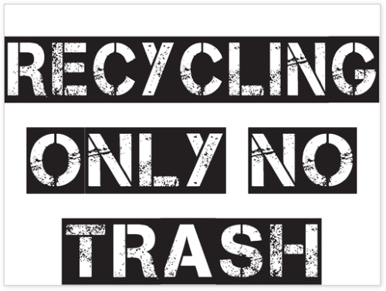

Will this project require ongoing funding? Do you have a plan for supporting the project in order to cover replacement, operation, or renewal costs?

The project should not require any ongoing funding. Extra magnets purchased can be used to replace worn/stolen magnets in the future.

Every project must be publicized! Where would you like to see information about this project reported?

I would like to see the project on the UIS snapchat story for a sustainable Tuesday. I also think that the newly labeled dumpsters should be put in the local newsletter from the RAs to their living areas. Finally, the dumpster labels should be featured on the UIS Green Projects Web Page.

