UIS Green Projects Application
Full Project Proposal- Step 2

To complete your Full Project Proposal, download this word document and type all answers to the questions below. Save your completed word document along with any supporting documentation (excel spreadsheet of budgeted itemized items, letters of support, and so on) as new files. Supporting files in Word (.docx) format should be attached to the end of this application in order to create only one Word document. Supporting files in all other formats (pdf, excel, PP) may be submitted as separate documents.

Once completed and saved to your device, return to the Green Projects website at http://www.uis.edu/greenprojects/get-involved/

Click the hyperlink titled, “Submit your completed UIS Green Project Proposal”
This can be found under Step 2 of the “Submit a Green Project Proposal” section.

You will be redirected to an external WebQ. Upload your completed application along with any supporting documentation by the deadline found in the “Timeline” section of the Green Projects website.

NOTE: Please do not submit this application unless you have been formally invited to do so by the UIS Green Fee Committee.

If you have any questions regarding the application or submission process, please contact us at greenprojects@uis.edu.

Project Name: Outdoor Recycling Bins

Contact Information:

Project Team
Name | UIS Student/Faculty/Staff & Department (or Office) | UIS Email | Phone #
Taryn Christy | UIS Student | Tchri2@uis.edu | 6307770409

Organization/Affiliation: Student

Project Information:

Provide a brief description of the project, its goals, and the desired outcomes:

This project aims to increase the number of outdoor recycling bins around campus. The primary goal is to increase the number of visible and usable recycling options that the UIS community sees while walking through campus. Ideally, this will encourage better recycling habits by making receptacles more accessible. The goal is for every outdoor garbage bin to eventually be accompanied by a recycling bin. The recycling bins should be cost effective and practical. Concrete bins are suggested, as they can withstand the elements.

How will this project improve sustainability at UIS?

This project will improve sustainability because currently there are not enough accessible outdoor recycling options around campus. I think that to promote more recycling around campus, each outdoor garbage can should be accompanied by a recycling bin in the long run. This proposal is centered around a pilot program of two to three receptacles. When garbage bins are not accompanied by recycling bins, it sends the message that everything should just be mindlessly thrown away instead of disposed properly. People on campus will think it is okay to throw everything in the garbage bin since they have “no other option.” Additionally, litter on campus can increase when there are not enough receptacles around.

Please indicate how this project will involve or impact students. What role will students play in the project?

The students will be affected by this project because it will remind them to be conscious of their waste discard habits. If they are walking across campus holding on to an empty water bottle, but the only thing immediately accessible is a lone garbage can, they may settle for the garbage can in their rush to class. That is a missed opportunity to recycle and the absence of the recycling bin in the proximity enables this habit to continue. This is an opportunity to combat the excuse that recycling is inconvenient, since there will be no extra time or energy exerted when the bins are right next to each other.

Where will the project be located? Do you need special permissions to enact the project at this site? If so, please explain and attach a letter of support to your application. If you are not sure, let us know! We can help.
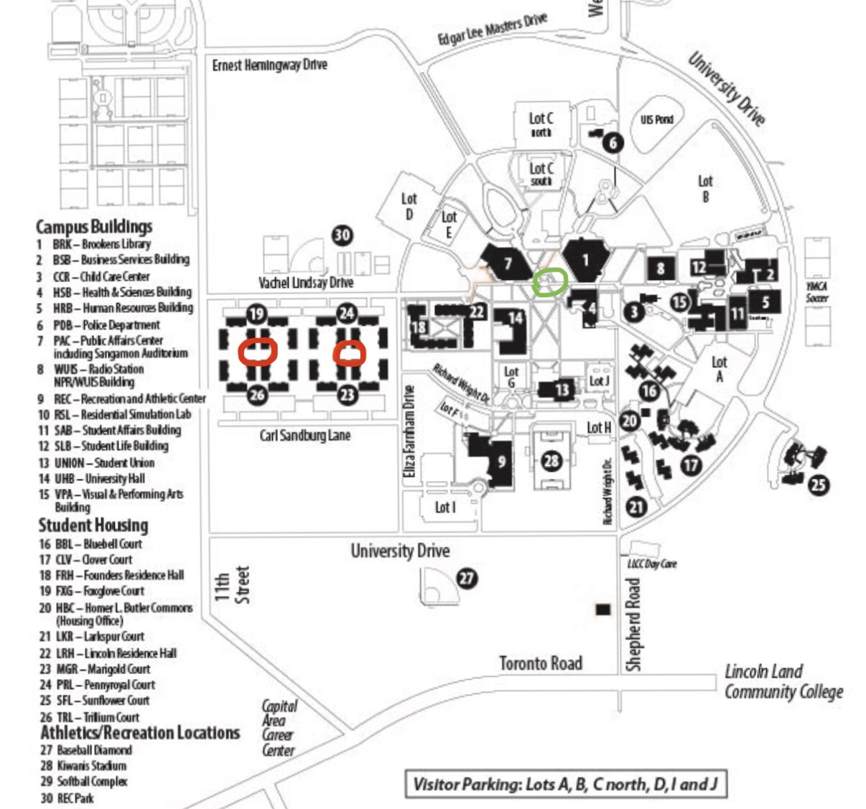

After discussing with multiple students, there is a strong need for recycling bins through the center of the townhouses for students walking to the main campus. I have received feedback that students are walking all the way to classes or the dorm with recyclable items in their hands. If we did a small pilot program of two outdoor bins, I would recommend either placing two bins in the red circles near the townhouses, or place one bin in the red circle and one bin in the green circle (between PAC and Brookens Library).

Other than the project team, who will hold stake in the project? Please list other individuals, groups, or departments indirectly or directly affected by this project. This includes any funding entities (immediate, future, ongoing, etc.) and any entities that will be benefiting from this project. Communication with affected departments is encouraged ahead of time. List the names of who you spoke with and their comments.

The grounds crew on campus will be affected by this project as it will increase the number of receptacles that need emptied. Ideally, the pilot program will not be excessively burdensome as an addition to their current maintenance. If this project expands further past the pilot stage, more coordination with the grounds crew may be required.

Have you applied for funding from the Student Green Fee previously? If so, for what project?
No, I have never applied for funding from the Student Green Fee before.

Scope, Schedule, and Budget verification

Do you have a plan for project implementation? Describe the key steps of the project.

Key steps:
- Determine final costs and approve funding late winter
- Select proper receptacles and organize implementation/labor late winter/early spring
- Order receptacles in late winter/ early spring
- Receive receptacles mid-spring
- Installation of receptacles by the end of the semester

List all budget items for which funding will be required. Include the cost for each item requested. Please be as detailed as possible, to the best of your ability. If you know where you would like to purchase materials from, please list the contact information of the retailer(s) below, along with the URL addresses to each item you will be requiring. If you need suggestions for how and where to purchase materials, please contact the Student Sustainability Projects Coordinators by email.

Here are the provided quotes for:

4 containers:
model RR4000: $2856
model LR2142: $3188

8 containers:
model RR4000: $5012.80
model LR2142: $5514.40

https://dotyconcrete.com/products/waste-containers/recycling-containers/

https://dotyconcrete.com/catalog/download-catalog-pdf/

Will this project require ongoing funding? Do you have a plan for supporting the project in order to cover replacement, operation, or renewal costs?

This project would not require substantial ongoing funding. After the initial cost of installing the new recycling receptacles, the emptying of bins would fall under the jurisdiction of the grounds crew. Hopefully the

Every project must be publicized! Where would you like to see information about this project reported?
This could be published online on the website or wherever you see best fit.

