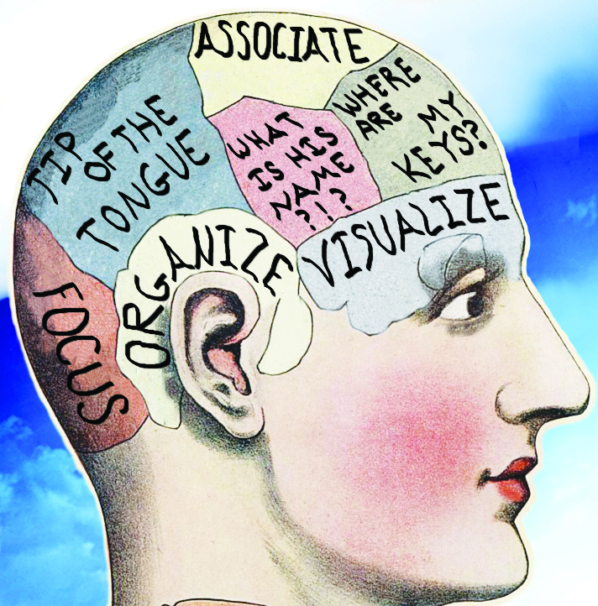
20 Memory Techniques
Utilize these techniques to develop a custom-made memory system that fits to your learning style.

- Organize it (Organizing Information is easier to find)

- Be Selective: Consider what is the most important to learn, Look at chapter previews, summaries, and review questions. Look at the visual elements such as charts or tables. Look at all the cues that may be important to know and develop questions for yourself that you may be tested on.
- Make it Meaningful: You remember things better if they have meaning to you. Create meaning in your learning from the general to the specific. By understanding the big idea, the easier it becomes for the details to make sense.
- Create Associations: The data already encoded into our neural networks are arranged according to a scheme that makes sense to us. When introducing new information, we can remember this information more effectively when it is associated with similar or related data.

- Use your body (Learning is an active process; get all of your senses involved)

- Learn Actively: Action is a great memory enhancer. Study assignments with the same energy that you bring to the dance floor or basketball court. For example, sit up straight at your desk, get up, walk around while studying, and use your hands and your mouth. Get your body moving to help enhance your memory.
- Relax: When you’re relaxed, you absorb new information quickly and recall it with greater ease and accuracy. Relaxation is a state of alertness and free of tension. This is the time when your mind can play with new information, roll it around, create associations, and apply other memory techniques. Information cannot be easily absorbed when you’re in a state of stress, being zoned out, drowsy, or asleep.
- Create Pictures: Use images to connect facts and illustrate relationships. Draw pictures, cartoons, or diagrams. You can “see” and recall associations within and among abstract concepts more easily when you visualize both the concepts and the associations together.
- Recite and Repeat: Reciting out loud utilizes two different senses. First the physical sensation in your throat, tongue, and lips when voicing the concept. Secondly your ability to hear it. Reciting out loud is more useful than reciting out loud in the library. Repetition is important because it is a memory device that works. Repeating information aloud makes it easier to travel through pathways in the brain helping you to remember. For example, create a song that pertains to the information being learned and sing it aloud.
- Write it Down: Writing engages a different kind of memory than speaking. Writing prompts us to be more logical, coherent, and complete. Writing is an effective way to prepare for tests especially when having more written tests than oral tests. Learning is an active process. Therefore, writing is physical and is helpful in engaging in that active learning process.

- Use your Brain (Work with your memory, not against it)

- Engage your Emotions: You are more likely to remember course material when you relate it to a goal-whether that is academic, personal, or career. The more goals you have and the more clearly defined they are, the more channels you create for incoming information. If you find a topic not interesting, then create interest.
- Overlearn: One way to fight mental fuzziness is to learn more than you need to know about a subject. Pick a subject apart, examine it, add to it, and go over it til it becomes second nature. For example, do assigned problems plus more. Make up your own problems and look at different books to really get a sense of the material being learned.
- Escape the short term memory trap: Short term memory can fade after a few minutes, and it rarely lasts more than several hours. A short review within minutes or hours of a study session can move material from the short term memory into your long term memory. This quick mini review can save you hours of study time when exams roll around.
- Use your times of peak energy: Study your most difficult subjects during the times when your energy peaks, whether that’s morning, afternoon, or night. Find the peaks and valleys of your energy flow and adjust your study time accordingly.
- Distribute Learning: Break up your study time into smaller shorter study sessions. For example have three 2 hour study sessions rather than a full 6 hour study session. Allow yourself to take breaks and to refresh your mind.
- Be aware of attitudes: If you think math is boring, you will have a harder time remembering equations. All of us forget information that contradicts our opinions. If you think that a subject is boring, remind ourselves that everything is related to everything else. Look for connections that relate to your interests.
- Elaborate: Elaboration means consciously encoding new information. Repetition is one basic way to elaborate. One example of elaborating is asking yourself questions about incoming information such as “Does this remind me of something or someone I already know?” “Where and when can I use this information?”
- Intend to Remember: Have the intention to learn about it now rather than later. This is a great intention to enhance your memory. Have a way to keep your mind focused. For example, every time your mind wanders in class, make a tick mark in your notebook. This act of writing will reengage your attention back to the lecture.

- Recall it (Recite and Apply Key Information)

- Remember something else: When you are stuck and can’t remember something that you’re sure you know, remember something else that is related to what you can’t remember. For example, if you can’t remember your great aunt’s name, remember your great uncles name. Any piece of information is encoded in the same area of the brain as a similar piece of information. You can unblock your recall by stimulating that area of your memory.
- Notice when you do remember: Everyone recalls information differently, whether that’s reading, hearing, seeing, or doing. It is important to develop your memory and notice when you recall information easily and when you don’t. Ask yourself which memory techniques work best.
- Use it before you lose it: To remember something, use it a lot. Even things in our long term memory become difficult to remember. The pathways to the information become faint when we disuse. To remember something, use it a lot. Read it, write it, speak it, and apply it. Find ways to connect to the material regularly. Another way is to teach it. When you can explain the information, you can really understand the material. (Teach in study groups. Proves to be very effective)
- Adopt the attitudes that you never forget: Rather than saying “I don’t remember” adopt the saying “It will come to me.” This statement implies that the information that you want is encoded in your brain and that you can retrieve it-just not at this moment. Remember to have positive thinking and use positive affirmations that support you in developing your memory. You will be pleasantly surprised how much you remember.

(Resource: “Becoming a Master Student” Thirteenth Edition by David Ellis Pages 102-107)

