Catering Services Menu
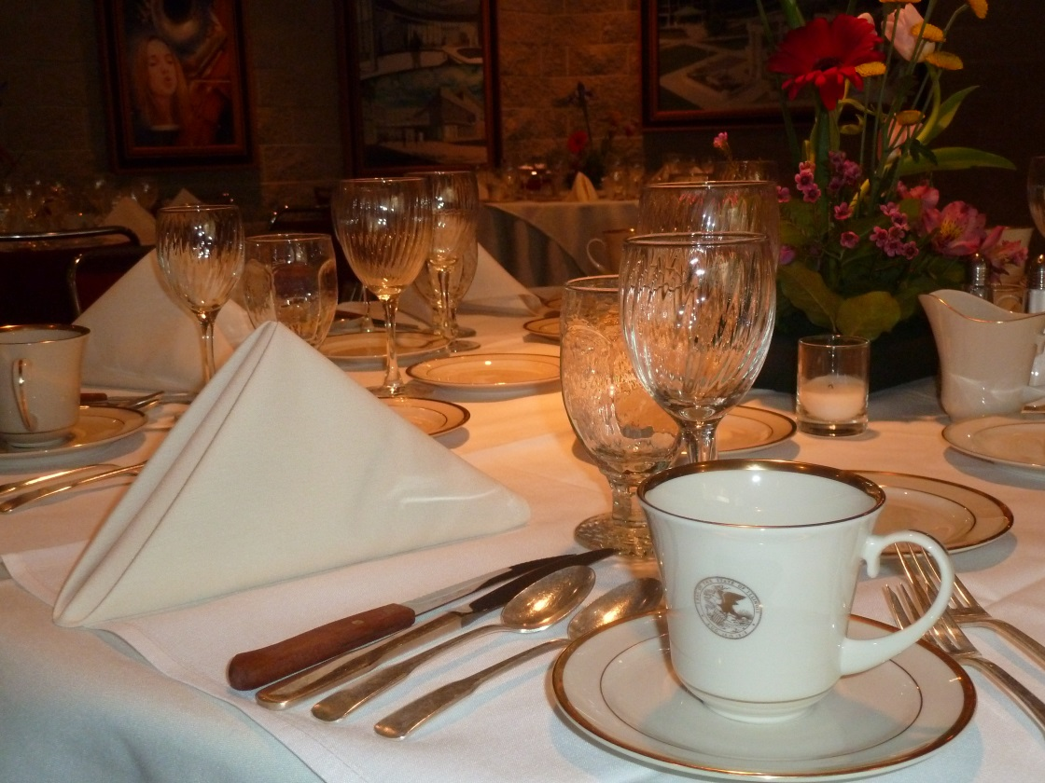

Whether you need coffee service for 25 people or a banquet for 200, UIS Catering can help. We provide a full range of catering services for events held on campus events.

University of Illinois Springfield
2251 Richard Wright Drive
Springfield, Illinois 62703
217-206-7741

TABLE OF CONTENTS
Catering Guidelines 3
Popular Breaks and Snacks………………………………………………………………..4
Breakfast and Brunch 5
Soups and Sandwiches 6
Fresh from the Garden 7
Classic Buffet Service 9
Buffet Enhancements 11
Plated Table Served Meals 12
Hors D’oeuvres 16
Desserts 20
Bar Service 22
Catering Services Policies 24

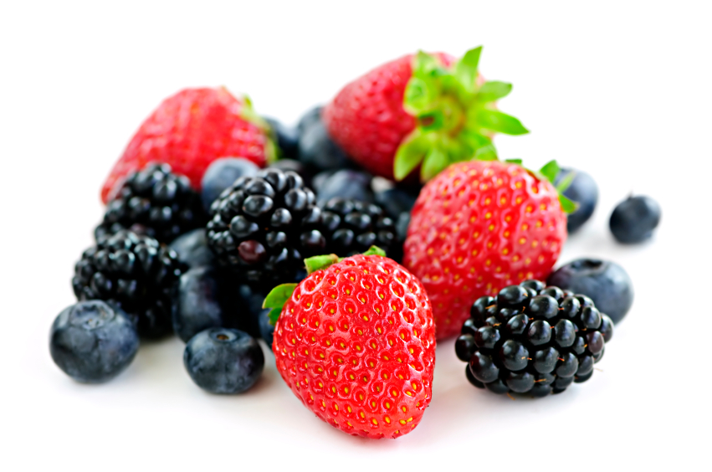

CATERING GUIDELINES
The planning for special events takes time and preparation. Please give us enough time to plan your event by adhering to the following guidelines:
- Space must first be reserved through either the Student Union 217-206-4782 studentunion@uis.edu or conferenceservices@uis.edu 217-206-6073

- Upon confirmation of space needs, the group or individual should contact
the Catering Department regarding food services: rwill6@uis.edu or 217-206-7741, Randy Williams

- All details for event including guaranteed guest count, room arrangements, media needs, programs or presentations and duration, shall be confirmed at least 10 “Working Days” prior to event. (Working Days will be understood to mean: Monday-Friday).

- Method of payment and billing information must be received prior to your event, including signed contracts. University of Illinois department clients must include following with all catering request. requests:
a. The name of the account to be billed.
b. The account number to be billed.
c. The name of the fiscal officer for account if applicable.
5. The final guarantee for guests will be due five working days prior to the event. The UIS Catering Service will set the room, and will be prepared to serve 5% over the guarantee number of guests.
6. We understand events arise unexpectedly and we will do our best to accommodate your needs. Late orders will be accommodated to the best of our abilities on a case by case basis including rush charges as follows:
48-72 Hours prior, 25% of the food & beverage bill
1-48 Hours prior, 50% of the food & beverage bill
POPULAR BREAKS AND SNACKS
Beverages
sold by the gallon serves approximately 15 people
Urn of hot water, Lipton, herbal teas, brewed Arabica coffee regular or decaffeinated - 22.00
Hot Chocolate - 22.00
Assorted 10 oz. bottles of juice: orange, grapefruit, apple, cranberry - 2.50e.
Bulk Juice: orange, apple, cranberry or tomato gallon - 12.00
Bottled Spring water - 2.00
Lemonade gallon- 21.00
Fresh brewed iced tea gallon - 19.00
Canned soft drinks – 2.00
Bakery
mini scone - 1.25
muffins - 2.00 mini muffin - 0.50
bagels with cream cheese (plain or assorted) - 1.50
cinnamon rolls - 1.50
petite danish - 1.25
granola bars – 1.50
brownie, powdered sugar - 1.50
cookies – 0.85
creamy lemon bars - 1.50
gluten free items - $ up-charge
whole fresh fruit: apples, bananas, oranges - 0.85

Continental Breakfast
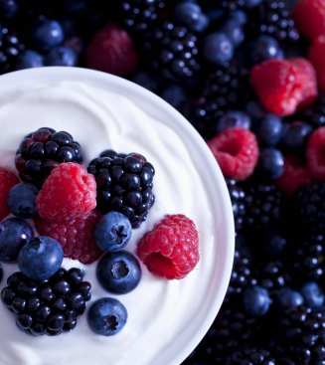
Assorted pastries may include: Scones, Danish, Doughnut holes & Muffins
Fresh fruit tray, coffee, decaffeinated coffee, assorted teas, chilled assorted bottled juice – 8.00
Add:
individual Greek yogurt containers - 1.50e.

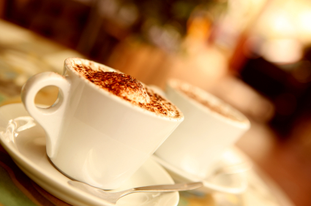
BREAKFAST
*buffet minimum of 25 guests. Prices based per person.
The Midwestern
Fresh cut seasonal fruit with Princess dressing, assorted petite muffins, Danish pastries, and cinnamon rolls, scrambled eggs, crispy bacon, and sausage link or patty, sliced American fries, fresh brewed coffee, decaffeinated coffee, hot tea, milk, chilled assorted juices, and ice water – 15.00
The Capital
Scrambled eggs, crispy bacon or sausage link or patty, seasoned cubed breakfast potatoes, French toast with maple syrup, seasonal fruit, pastries, fresh brewed coffee, decaffeinated coffee, assorted teas, chilled assorted bottled juices – 15.00
The Prairie
Fresh sliced melons, pineapples, orange wedges, strawberries, and grapes with princess dressing, scrambled eggs, bacon, and sausage with buttermilk biscuits and gravy, seasoned breakfast potatoes, assorted preserves and butter, fresh brewed coffee, decaffeinated coffee, hot tea, milk, chilled assorted bottled juices, and ice water – 16.00
The Healthier Side
Diced fresh fruit and berries, Greek yogurt with granola, hard boiled eggs, whole grain bagels with light cream cheese, fresh brewed coffee, decaffeinated coffee, assorted teas, chilled assorted bottled juices – 13.00
Bagel Bar
Assortment of Bagels with Butter, Cream Cheese and Jellies. Seasonal fresh fruit tray, fresh brewed coffee, decaffeinated coffee, assorted teas, chilled assorted bottled juices – 12.00

Chef-attended exhibition omelet station
additional $7 per person on any hot breakfast buffet
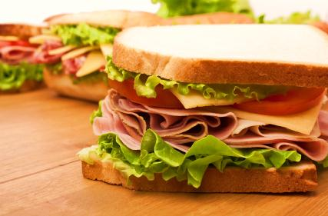
SOUPS AND SANDWICHES
Signature Soup
Minimum of 25 people
Midwest vegetable, roasted corn chowder, loaded baked potato, Asian hot and sour, beef and barley, herbed tomato bisque, cream of broccoli, Louisiana gumbo, or soup du jour – 4.50
Deli Buffet
Combination of: freshly sliced hickory smoked turkey breast, shaved ham, top round roast beef, and hard salami. Includes: sliced onions, tomatoes, crisp lettuce, dill pickle slices, brown mustard, mayonnaise packs, honey mustard, chipotle ranch or pesto mayo.
Cheese: cheddar, provolone, Swiss, pepper jack or American
A variety of fresh breads including: whole wheat, white, rye, sour dough, or sweet French sub

Fresh fruit compote, potato salad or pasta salad, assorted fresh baked cookies, brownies, or creamy lemon bars
Fresh brewed coffee, iced tea, and water – 15.00

Sandwich Options
Talk to Catering sales for selections.
Boxed Lunches
Breads and sides must be the same for the entire order. Sandwiches are made with whole wheat sub rolls with lettuce and tomato. Choice of sandwich: roast beef, turkey, ham, chicken salad or vegetarian. Includes potato chips and seasonal fruit, pasta or potato salad, cookie and beverage – 12.00

FRESH FROM THE GARDEN
Salads include Artisan bread and choice of dressing
Grilled Chicken, Salmon or Shrimp Caesar Salad
Classic Caesar salad tossed in our Caesar dressing with grilled chicken breast, salmon fillet or shrimp topped with shaved parmesan cheese and croutons – 14.00

Cashew Chicken Salad
Mixed greens, topped with marinated and grilled chicken breast, mandarin oranges, cashews, chow mein noodles, vegetables, and Asian ginger scallion dressing – 12.00
Greek Chicken Salad
Romaine with grilled marinated chicken with artichoke hearts, Kalamata olives, tomatoes, red onions and feta cheese with Greek Dressing. – 13.00
Alà Carte Side Salads
Caesar Salad
Classic salad with Romaine, special Caesar dressing, parmesan cheese, and homemade croutons – 4.00
Tuscan
Romaine and leaf lettuce, sliced Roma tomatoes, slivered red onions, shredded parmesan cheese and croutons, sweet vinaigrette - 4.50
Garden Tossed
Blend of three greens, sliced cucumbers, tomato wedges, carrots, red cabbage, feather shredded cheddar cheese, with choice of dressing - 4.00
Spring Mesclun *served all year*
Gourmet baby greens, with a medley of dried fruits, mandarin oranges, pecans, Havarti cheese julienne, with choice of dressing - 4.75

Spinach Tossed
Baby spinach with sliced hard-boiled egg, grape tomatoes, red onions, sliced strawberries, and crispy bacon, topped with poppyseed dressing – 4.00
A K Tossed
Chopped kale and arugula tossed with grape tomatoes, shaved red onions, shredded carrots and sliced almonds, topped with a vinaigrette – 4.00

Additional Salad Dressing Selection:

Buttermilk Ranch
Golden Italian
Bleu Cheese
Poppy Seed
French
Parmesan Peppercorn
Honey Mustard
Sweet Tuscan
Raspberry, Champagne or Balsamic Vinaigrette
Vidalia onion

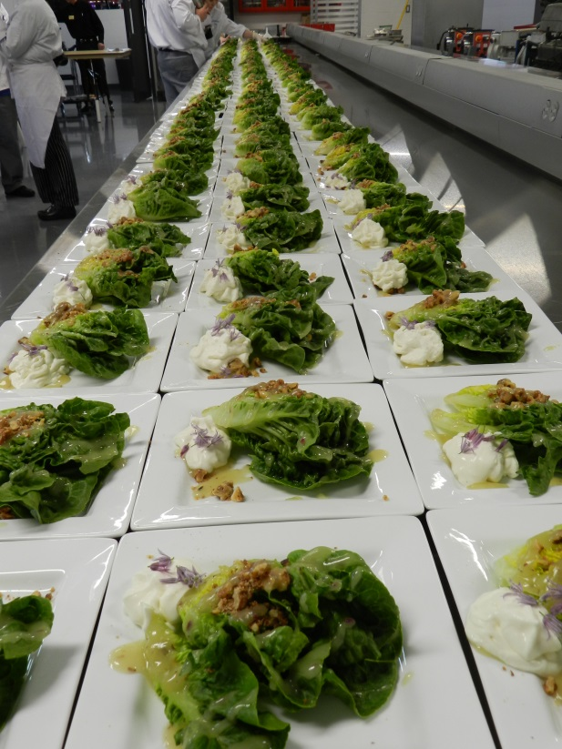

CLASSIC BUFFET SERVICE
All buffets are priced per person (25 person minimum)
All buffets may include dinner rolls and beverages. Unless otherwise designated, salads, sides and desserts may be added for an additional charge
The French Quarter
Ponchatoula salad with mixed greens, strawberries, red peppers, carrots, and sweet, Creole vinaigrette, marinated vegetable salad, Louisiana Gumbo, grilled chicken Tchoupotoulas, down and dirty rice, roast corn maque choux, roasted pecan sautéed green beans, bread pudding with bourbon sauce – 20.00
Cape Cod
Corn chowder, fresh greens with vegetables, cranberries and dressings, roast chicken with apple cider sauce. Maryland crab cakes with red bell pepper aioli, garlic lemon new potatoes, green peas with mushrooms and almonds, steamed medley of broccoli, cauliflower, Brussels sprouts, hot apple cider crisp with vanilla ice cream – 20.00
Asian Express
Asian salad, Szechuan beef and broccoli and General Tso’s Chicken, vegetable fried rice or lo mein, egg rolls, pot stickers and dipping sauces, Asian stir fried vegetables, Mandarin sweets – 19.00
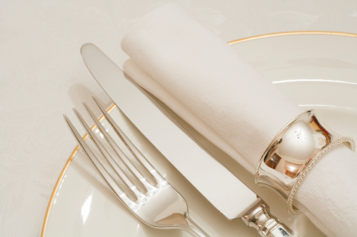
Rail Splitter
Fresh fruit compote, potato salad, BBQ breast of chicken, sliced smoked beef brisket, buttered corn, smothered green beans, bacon, and onions, creamy macaroni and cheese, cornbread and assorted cheesecakes – 21.00
Taste of India
Chicken Tikka Masala or Chicken Vindaloo, Vegetable Biryani, Basmati Rice, Naan bread, Yogurt dip. Includes dessert – 18.00
SALAD AND BAKED POTATO BAR
Vegetarian Bean Chili, Baked Potatoes, Romaine Lettuce, Grilled Chicken and Beef Strip, Cheddar Cheese, Bacon Bits, Broccoli, Tomatoes, Green Onions, Parmesan & Cheddar Cheese and Croutons accompanied by Ranch Dressing. – 15.00
Southwestern Grill
Fresh cut fruit tray, Southwest pasta salad, soft, warm flour tortillas and crispy taco shells, seasoned taco beef and grilled fajita chicken with peppers, toppings: grated cheddar cheese, diced tomatoes, lettuce, jalapenos, black olives, sour cream, and guacamole, Texas rice, cake and fresh tortilla chips sprinkled with cinnamon and sugar – 15.00
Little Italy
Italian style salad with sliced Roma tomatoes, croutons, parmesan cheese, shaved red onions, green olives and sweet Tuscany dressing, penne pasta salad with vegetables and tomatoes, baked lasagna with meat sauce, grilled basil chicken, rice pilaf with sun dried tomatoes, sautéed Italian vegetable medley with balsamic vinegar, lemon chiffon torte with raspberry sauce – 19.00
The Homestead Choice of Two Entrées:
Slow cooked beef pot roast crispy fried chicken or meatloaf. Served with choice of two: mashed potatoes, macaroni and cheese, red skin potatoes and carrots, seasoned country style green beans with bacon and onions, includes tossed green salad, warm roll and butter, assorted cookie, brownie, or warm fruit cobbler – 21.00
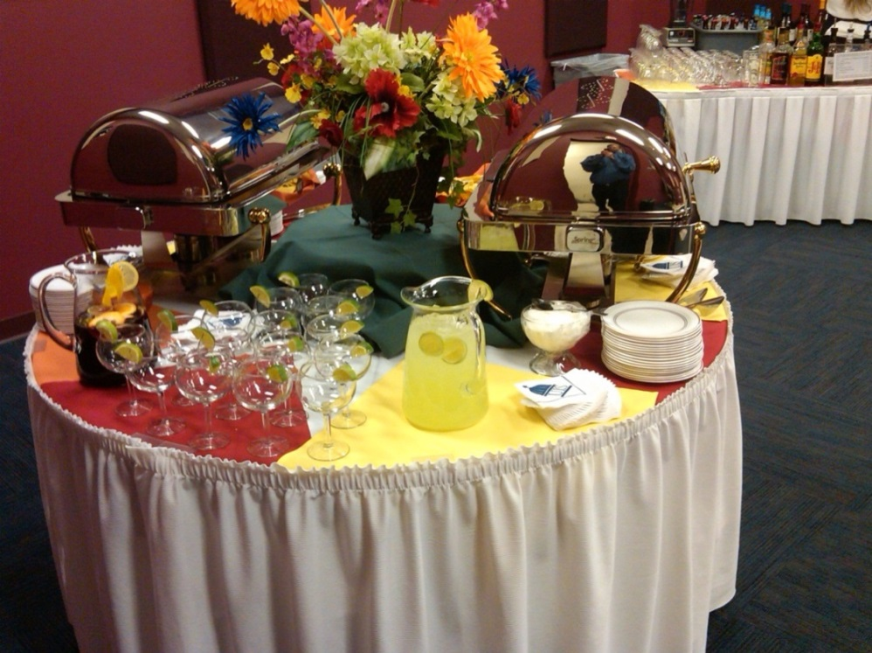
The All American Grill
Green tossed salad with Ranch dressing, potato salad, house made potato chips, hamburgers, hot dogs, assorted condiments and buns, brownies, iced tea and lemonade – 15.00
Pasta Bar
Classic Caesar Salad, Choice of two pastas (fettuccini, penne, spaghetti, bow tie or cheese tortellini), choice of two sauces (marinara, Alfredo, pesto, Bolognese), choice of two meats (meatballs, Italian chicken, Italian sausage), garlic bread, brownies or cookies. – 14.00
BUFFET ENHANCEMENTS
your choice a la carte 2.00
Potatoes
Rosemary roast potatoes, twice baked potatoes, baked potatoes, parmesan potato planks, Lyonnaise potatoes, baked sweet potatoes served with butter and brown sugar, hash brown gratin.
Selection of mashed potatoes
Classic with cream and butter, bleu cheese red skin mashed, mashed Yukon gold with garlic topped with olive oil and fresh basil
Rice and grain dishes
Vegetable rice pilaf, Vegetable Jambalaya, Risotto, Quinoa, Basmati Rice
Pasta dishes
Pasta steamed with herbs and olive oil, Israeli cous cous pilaf, lemon orzo, fettuccini Florentine, mac n cheese
Vegetables
Sautéed green beans with pecans or bacon and onions, broccoli and cauliflower, buttered sweet corn, roasted root vegetables, asparagus, carrots with the choice of dill butter, or cinnamon glaze
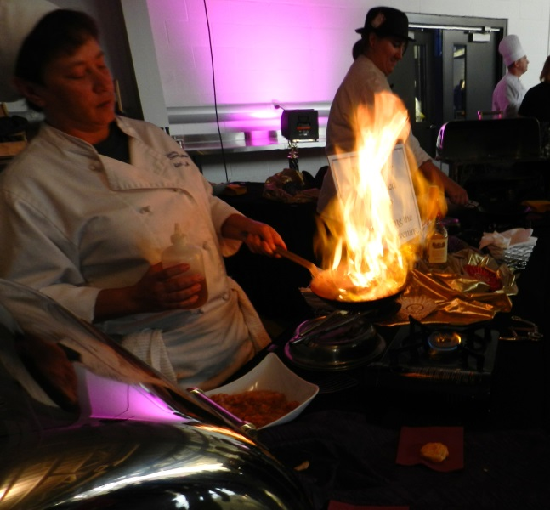
Vegetable medleys
Italian- zucchini, yellow squash, green beans, onions, red peppers, cauliflower
Midwestern-carrots, roasted corn, and tomatoes
West Coast- spinach, beets, squash, peppers, artichoke hearts
Whole earth- roasted root vegetable with carrots, beets, squashes, turnips, parsnips

PLATED TABLE SERVED MEALS
All meals are priced per person (25 person minimum) includes dinner rolls and beverages
Unless otherwise designated, salads, sides and desserts may be added for an additional charge
Poultry selections
Miami Citrus Chicken- citrus marinated and grilled, boneless chicken breast topped with a mirepoix of chopped mango, strawberry, and pineapple – 12.00
Teriyaki Chicken- marinated and grilled boneless breast, served with grilled pineapple and a slightly spicy oriental BBQ sauce – 12.00
Chicken Louisianan- seasoned and grilled chicken breast, accompanied with shrimp and crawfish in a light and flavorful Cajun cream sauce – 13.00
Acapulco Chicken- marinated boneless chicken, grilled, and topped with a gratin of goat cheese, chorizo, mushrooms, onions, tomatoes and a southwest style cream sauce – 12.00
Chicken Romana- grilled boneless chicken, served with tomato sauce, topped with fresh mozzarella, roasted garlic and pesto drizzle – 12.00
Chicken Marsala- boneless breasts, seasoned and sautéed with a rich Marsala wine sauce with mushrooms and pearl onions – 10.00
Chicken Ala Greque- marinated chicken, grilled and accompanied with a mélange of artichokes, kalamata olives, peppers, in an oregano-garlic glaze – 11.00
Apple Almond Turkey- tender roasted breast, sliced and served with an apple and raisin compote, along with a honey almond sauce – 11.00

Pork selections
Grilled Pork Bayou Teché- twin medallions of pork loin, served with a Creole mustard cream sauce, julienne pickles and bell peppers – 13.00
Roast Pork Waldorf- roasted loin of pork, carved and served with apples, walnuts, and celery in a lightly sweetened herb cream sauce – 13.00
Rosemary Roast Pork- marinated and roasted pork loin, served with a savory herb jus and sun dried tomatoes – 12.00
Apricot Pork- grilled medallions of pork, served with a sherry apricot glaze, poached apricots, raisins and shallots – 13.00
Roast Pork Cape Cod- boneless loin, seasoned and roasted to medium, knapped with a cranberry port wine sauce with roasted walnuts – 9.00
Prime Rib of Pork- bone in roasted rack of pork, cut into chops, served with a red wine jus and mushrooms – 12.00
Roast Pork with red onion jam- herb rubbed, roast, and carved, served with a sweet and tart, caramelized onion preserves – 11.00
Beef selections
Roast Round of beef chasseur- sliced roast beef, roasted and served with a sauce of Demi-glace, white wine, tomatoes, mushroom and onions – 11.00
Roast Strip Loin of beef- smoked, seasoned, and slow roasted, a half-pound cut is served with a piquant peppercorn mushroom demi-glace – 18.00
Filet Mignon- the tenderest cut of beef, seasoned with our own house herb rub, grilled, and served with a mushroom red wine sauce. Priced at market price.
Roast Rib of Beef- 8 oz. slice is served with a rich rosemary au jus and horseradish sauce – 21.00

Pasta selections
Beef Lasagna- topped with a light marinara sauce, and garlic breadsticks – 11.00
Vegetable Lasagna- topped with a light Alfredo sauce, and garlic breadsticks –11.00
Chicken and Fettuccini Gorgonzola- grilled chicken over fettuccini alfresco tossed with Italian gorgonzola cheese – 13.00
Portobello Ravioli Primavera- stuffed pasta pouches, tossed with fresh sautéed vegetables in pesto olive oil – 13.00
Creole Linguini Atchafalaya- shrimp, tuna, and scallops, with tomatoes, onions, peppers, and celery, tossed with pasta and a spicy Creole herb sauce – 14.00
Greek Chicken and orzo pilaf- rice shaped pasta with chunky tender chicken, plentiful vegetables and herbs, cooked in a rich chicken broth, 13.00
Chicken and Tortellini Formaggio- julienne chicken, four cheeses: Swiss, mozzarella, parmesan, and a touch of bleu, tossed with pasta, cream and spices – 9.00
Farfalle Pasta Nouvelle- bow tie noodles, abundance of vegetables, wild mushrooms, garlic, olive oil, feta cheese, and lemon – 9.00
Ultimate Mac and Cheese- chicken, sausage, and shrimp, mushrooms, asparagus, and peppers, along with gemelli pasta, in a light herbed smoked cheddar cheese sauce – 10.00
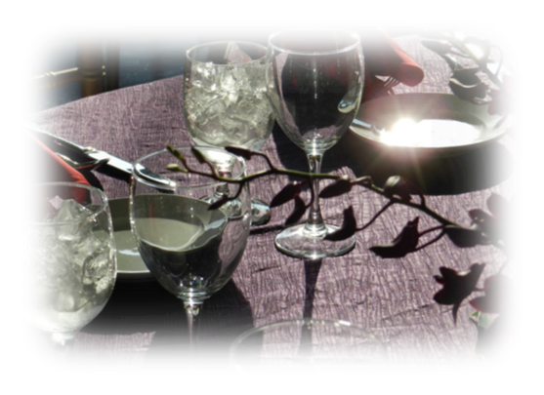
Seafood selections
Atlantic Tilapia- 11.00
choose your preparation:
lemon pepper baked with dill sauce
panko crusted with garlic herb butter
Cajun bronzed with lemon and parsley
Salmon – 15.00
choose your preparation:
Grilled with herbs and lemon butter
Bourbon pecan maple glazed
Marinated, pan seared with Asian miso, sesame seeds, and scallions

Shrimp and scallop risotto- creamy Arborio rice, with shrimp and scallops, tomatoes, red onions, zucchini, kalamata olives, and parmesan cheese – 13.00
Chesapeake Crab Cakes- flaky and delicious, pan fried classic served over a smoked tomato sauce, with pine nuts and leeks – 11.00

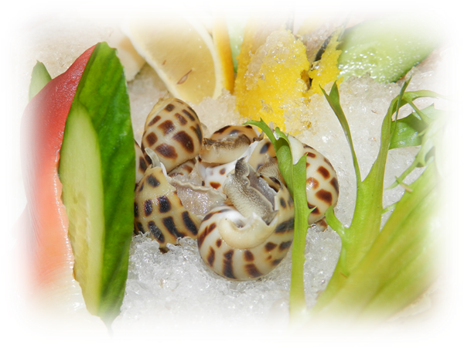

HORS D’OEUVRES
Our dazzling display of buffet style hors d’oeuvres serves 50 unless otherwise noted.

Cold Hors D’oeuvres
Devilled eggs - 35.00
classic or with smoked salmon mousse
Bruschetta fresh tomato and cheese with crostini -60.00
Fresh fruit kabobs with yogurt dip - 50.00
Silver Dollar size sandwich assortment - 48.00
Seared scallops with dill cream - 85.00
Shrimp cocktail shooters - 90.00
Assorted deli wraps - 55.00

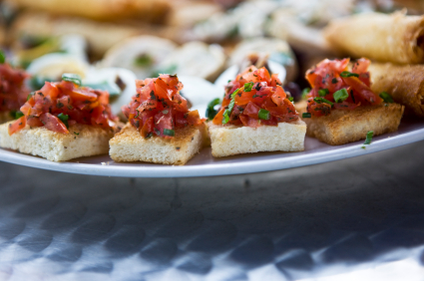
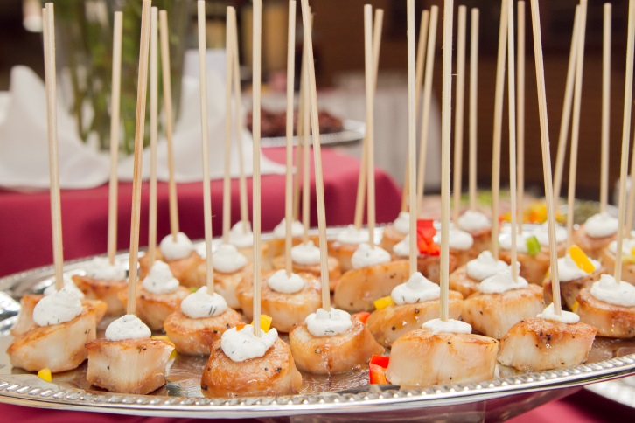

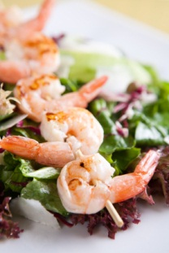
Hot Hors D’eourves
Assorted baby quiche - 70.00
Vegetable or pork egg rolls – 50.00
Honey battered chicken drumettes – 60.00
Fried ravioli, beef or cheese served with marinara - 45.00
Fried mozzarella cheese sticks served with marinara - 45.00
Savory Meatballs - 45.00
sweet and sour
BBQ
marinara
Chicken wings, buffalo or BBQ – 80.00
Brie & Pear Fillo purses with toasted almonds – 75.00
Rumaki: bacon wrapped scallops – 75.00
bacon wrapped date or water chestnut - 65.00
Stuffed mushrooms - 65.00
crab imperial
Italian sausage and marinara
Pot Stickers with ginger soy sauce – 65.00
Vegetable Spring Rolls– 55.00
Rustic Flatbread with tomatoes, olives, goat cheese, peppers - 65.00
Baked Brie en croute, French bread, red onion jam - 65.00
Gourmet sliders – 4.50 each
Angus beef tenderloin with caramelized onions and jack cheese
Blackened salmon with asparagus and sun dried tomatoes
Grilled turkey and Havarti with cranberry mayo

Displays (mirrors, blocks and trays):
Fresh sliced seasonal fruit with yogurt dip
Fresh raw vegetable crudité, relishes, and dips
Domestic and imported Artisan cheese block displays - French bread/crackers
Charcuterie & Artisan cheese block displays – 95.00
Small (serves 25) - 50.00
Large (serves 70) – 95.00
Charcuterie assortments available (ask for selections and market price)
Marinated grilled vegetables (serves approximately 50) - 75.00
Smoked salmon plank with appropriate accompaniments - 90.00
Maize and Blue Tortilla chips with salsa – 32.00
House made potato chips with French onion dip - 32.00
Sun dried red pepper hummus with toasted pita points - 32.00
Mixed nuts - 10.00 per lbs.

Chef’s carving station
* minimum of 50 guests *one hour service
Beef : (serves approximately 50)
Medium rare roast top round of beef or strip loin - 495.00
Prime Rib - 495.00
Served with Bordelaise sauce or Rosemary Jus and Horseradish sauce
Herb crusts roast tenderloin of beef - 495.00
Served with béarnaise
Honey roasted bone in country ham - 295.00
Dijon/ maple mayo/ buttermilk biscuits
Roasted breast of turkey - 295.00
Cranberry-Orange Relish, Dijon Mustard and Natural Gravy
Dry rubbed and smoked, roast loin of pork - 250.00
Creole mustard/ BBQ sauce

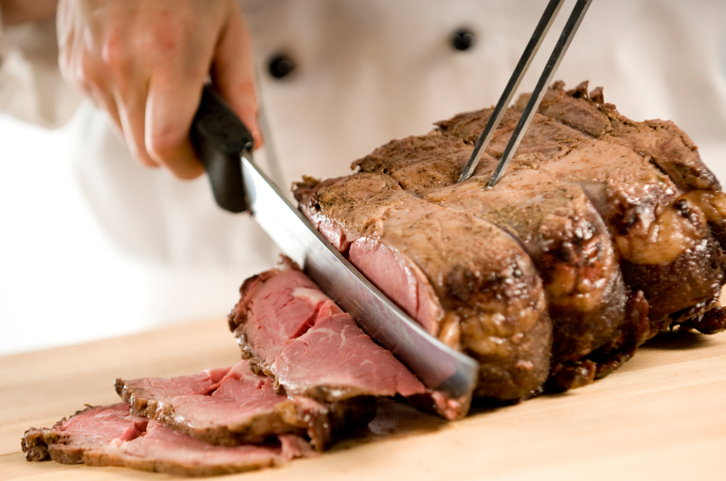

Dessert Selections
Gourmet Tortes (check for current sinful selection!) 4.50 per person
Lemon chiffon wedge over raspberry sauce, Red Velvet, Double Chocolate, Carrot, Tiramisu
Assorted pies: Chocolate, lemon meringue, coconut cream, cookies & cream, chocolate mint and Boston cream.
Sweet Treats
Tuxedo dipped strawberries - 80.00
Fresh baked brownies - 42.50
Lemon bars with powdered sugar - 42.50
Assorted cookies - 10.20 per dozen
Miniature Desserts
Assorted cheesecake bites - 75.00
Turtle caramel filled chocolate cups - 65.00
Petite chocolate éclairs - 45.00
Petite cream puffs - 45.00
Assorted petit fours - 42.50
Blondie toffee crunch bars - 42.50
Caramel Apple Dessert bars- 42.50

Dessert Stations
*50 guest minimum
Cheesecake – 5.50 per guest
Cheesecake bar with chocolate, cherry, strawberry, raspberry, blueberry, caramel sauces, pecans, chocolate chips and whipped cream.
Sweet Station - 6.50 per guest
Chocolate éclairs, blondie toffee crunch, fruit tarts, fruit kabobs, chocolate chip cookies, brownies, and cream puffs.
Ice Cream Sundae Bar - 6.50 per guest
Vanilla ice cream with toppings - chocolate, caramel, strawberry, whipped cream, chopped nuts and maraschino cherries.

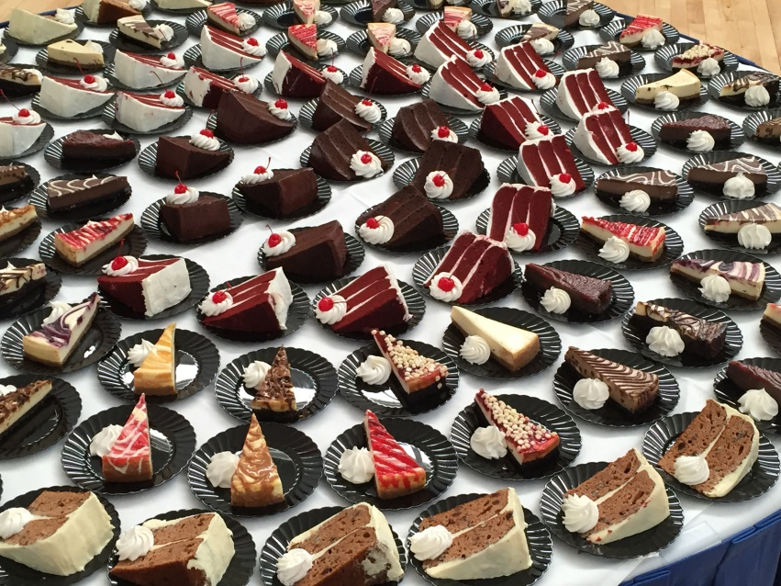

BAR SERVICE
Bars can be provided for your event. Bars may be open bar (hosted), cash bar, or a combination. A flat rate of $100.00 for bar setup and break down will apply to all events. Additional fees may apply for extended hours of service.

CONSUMPTION & CASH BARS
Consumption Bar
For those who wish to pay for each drink their guests actually consume.
Liquor is charged by the tenth of the bottle. Wine is charged by the
number of bottles opened. Beer is charged by the bottle.
Cash Bar
For those who wish for their guests to pay for their own drinks.

Bottled Beer
Domestic $4.00/bottle
Micro Brews/Imported $5.00/bottle
Our bars offer the following spirits for drinks:
Rum, Amaretto, Gin, Vodka, Whiskey, and Scotch
Call brand liquors - 6.00
Premium liquors - 7.00
Signature Drinks
This is a fun way to bring the color palate of your event to your guests. Signature drinks come in many styles and types. We can create fun drinks based on your favorite libation. Signature drinks are a custom menu item.

Wine
*sold by the bottle except for cash bars in which it is $5 per glass
Red Wine (California)
Merlot Pinot Noir Cabernet Sauvignon
White Wine (California)
White Zinfandel Pinot Grigio Chardonnay Moscato
Vintage, Illinois, and Sparkling Wine are available upon request
*Our catering department will be happy to assist you in the selection of wine to complement your banquet or reception.

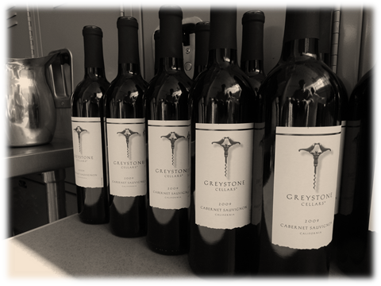

CATERING SERVICES POLICIES
The UIS Food Service has exclusive rights to all food and beverage service on campus. Food and beverages may not be brought into any event without express, written permission re: (Request to Waive Catering Requirements) from UIS Food Service Management.
Service Charge
All Food and Beverage prices are subject to the standard 20% service charge and 9.75% Illinois state sales tax, with a $5 minimum service charge. All menu items, charges and tax are subject to change without notice.
We require an additional 20% service charge for all events located off the UIS central campus. If an additional vehicle is required to transfer food or equipment to the event location, additional fuel or rental fees may be necessary.
We understand events arise unexpectedly and we will do our best to accommodate your needs. Late orders will be accommodated to the best of our abilities on a case by case basis including rush charges as follows:
48-72 Hours prior, 25% of the food & beverage bill
1-48 Hours prior, 50% of the food & beverage bill
Additional rental fees may be charged for china and glassware.
Pricing and Minimums
All prices quoted are based on a one-hour meal service period for events scheduled on campus, for groups of twenty-five or more. We require a minimum food service order of $450.00 for events scheduled on weekends, unless prior approval is arranged with UIS Food Services.
Unused Food
To prevent the mishandling of our food, it is our policy to not allow any food to leave an event. Health department regulations and liability concerns prevent us from allowing the removal of leftover food items. This will be enforced for your safety and the safety of the guests.
SPECIAL DIETARY NEEDS
We are pleased to provide quality meals for your special needs guests. Please plan to provide us with a guarantee of vegetarian, vegan, gluten free, or special plates needed for your guests. Special meal arrangements must be made in advance.

Cancellation
We kindly request that cancellations be made 5 business days prior to the event date. Cancellations made in less than five business days prior to the event date will be billed 50% of the total bill. Catered events cancelled less than two business days prior to the event date will be billed for 100% of the total bill. Extreme and inclement weather cancellations are excluded. This occurs only when the University is closed due to inclement weather.

Payment Details
A booking fee (non-refundable) of 25% is due at time of contract signing to guarantee a hold on the date for your function. The final payment is due the day of your event with your final count. The final payment is subject to revision if changes are made to the contract. If any additional expenses are incurred during your event, you will be billed after your event(s) and have 5 days to make final payment.

Alcohol
The UIS Food Service is the sole agent for all sales and service of alcohol on the UIS campus. Alcohol may not be brought on, or served on University property without the express involvement of the UIS Food Service.
All groups requesting alcohol service must first initiate an Alcohol Authorization form. These forms are available online. A copy of this form with the appropriate signatures authorizing sale or serving of alcohol must be delivered to the UIS Food Service at least 5 working days prior to the event. Additional procedures concerning security may need to be followed depending on the type of event and audience. We are required by state law to enforce the legal minimum drinking age requirements. We reserve the right to refuse service to anyone who appears to be intoxicated or behaving in an abusive manner.

Decorations
We make no provisions for decoration of banquet tables; this is left to your wishes and taste. The following items may be added for a minimal cost to enhance your event: bud vases, floral centerpieces, colored overlays and votive candles.
Event Serving
It is our desire to serve you promptly at the hour you select. Normal practice will be to allow your group access to the dining area fifteen minutes prior to the specified serving. In the case of a buffet format, the buffet line will be ready for service, except for the removal of chafing lids, fifteen minutes prior to the specified meal time.
If your event starts 30 minutes or more past the designated time an additional labor fee may be assessed and the quality of your food may be affected.
In cases where a program follows a meal, we will need time to clear the tables before the presentation begins. You may either break for an intermission, or remain seated and allow our servers approximately 10 minutes to complete clean up. If time constraints do not allow for this clearing and the excusing of staff, there will be an additional labor charge for the required personnel.
Thank you
Our culinary team has created this catering guide to help you plan and host your event. The menus listed are only a few of the options available through our catering service. We can also customize your event to meet your unique needs and tastes. Our chefs and staff have the expertise to provide for almost any menu request. Thank you for choosing UIS Catering Services. We are excited about the opportunity to help make your event a memorable occasion.

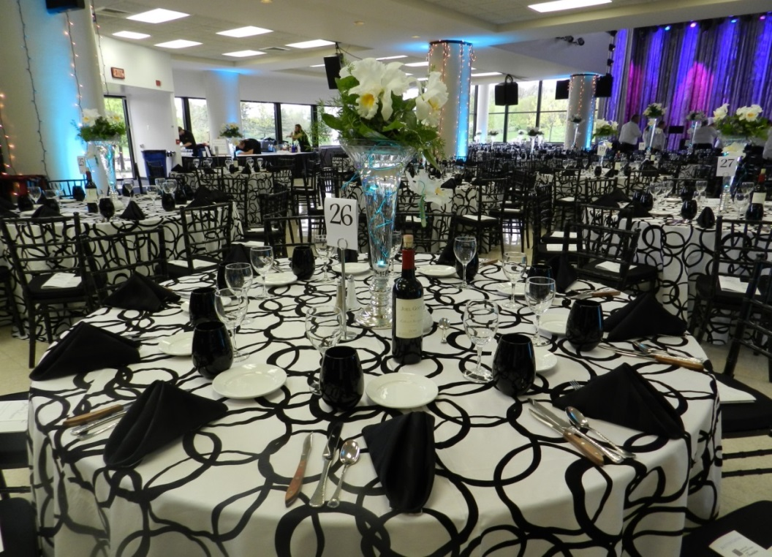

Updated 8/18

