Rassule Hadidi
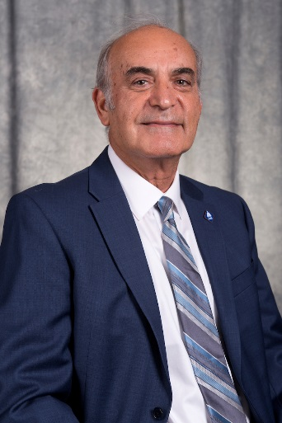
Rassule Hadidi joined the UIS/SSU faculty as an assistant professor in the Mathematical Systems Program in 1981, after having earned his Ph.D. from the University of Missouri-Columbia. He was promoted to associate professor in 1985, awarded tenure in 1987, and promoted to full professor in 1996.
Dr. Hadidi was instrumental in the development of UIS’ master’s degree in Management Information Systems (MIS) and served as convener from the program’s inception. He served most recently as head of the MIS Department from 2016 until his retirement. Professor Hadidi developed and offered one of UIS’ first fully online graduate courses in 1997, and he taught 14 different graduate and undergraduate courses. Dr. Hadidi’s research interests include healthcare informatics, quality of healthcare data, cloud computing, online and blended teaching and learning pedagogy, and curriculum development and quality assessment. He received the Hanson Professional Services Faculty Scholar Award in 2007 and the Faculty Excellence Award in 2016.
Professor Hadidi published more than 60 peer-reviewed articles and delivered more than 65 presentations at professional conferences. His external service includes responsibilities as President and At-Large Director of the Midwest United States Association for Information Systems, and founding and currently Managing Editor of the Journal of the Midwest Association for Information Systems. Dr. Hadidi is also a member of the Board of Directors of the Society for Advancement of Management.

Donna Haynes
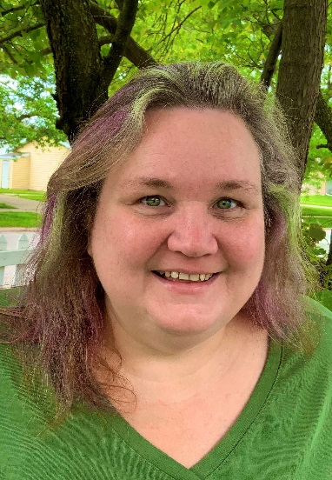
Donna came to UIS in the Fall of 1989 as a student in Accountancy. As a student, she was one of the founding members of the Sharing Tree. Shortly after earning her BA in Accountancy she started working full time for the University in what was Continuing Education. While working fulltime, she decided to return to the classroom and get her MS in Management Information Systems. For her Masters project, Donna developed a work order system to not only schedule Conference Center locations but to track and distribute information for every event, something that was desperately needed by the department. After 20 years, the system is still the backbone scheduling software for Conference Services. She continues to learn outside of the classroom through various conferences and certification programs; right now, she is in the inaugural Business Administrator Certification Program.

Donna has worked her way up through the ranks of the department beginning as an Account Tech to finishing up her career at UIS functioning as the assistant director at the end of 2019; during that time, she built up continuing education grants to over $500,000 annually until the budget crisis hit the state. Donna began adjunct faculty for the MIS department in the Spring of 2012. Donna also served the campus through various committees including APAC (2012 to 2019), Campus Planning and Budget Committee (2006-2019), State Universities Retirement System Members Advisory Committee (2013 to 2019) and Civil Service Advisory Committee (1998-2004) to name a few from over the years.

Joanne Hoagland

Judy Hughes
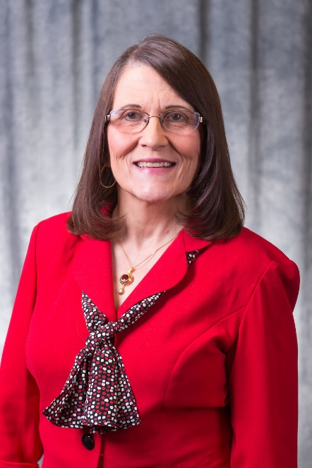

Carol Jessup
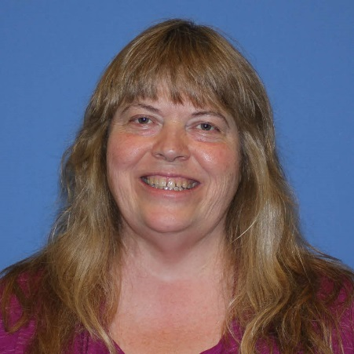
Carol M. Jessup earned her Ph.D. in Business Administration from Saint Louis University, with a major in Management and a minor in Public Policy Studies. She taught in the UIS Accountancy Department for 20 years. Professor Jessup primarily taught and researched in the areas of auditing and governmental and nonprofit accounting; her research interests also include fraud and online learning topics. She has written and reviewed CPA Exam questions, and she is being honored in June with a leadership award from the Illinois CPA Society. Dr. Jessup is currently Editor-in-Chief of The North American Accounting Studies and chairs the Editorial Board for the Journal of Government Financial Management of the Association of Government Accountants. She has served UIS on various committees.
In addition to her academic experience, Dr. Jessup held several positions in state and local government. She was a grant accountant, an internal auditor, served as a staff member of the team that implemented Generally Accepted Accounting Principles (GAAP) in the State of Illinois, managed a municipal finance department, and provided expert witness testimony in utility regulatory proceedings. Dr. Jessup serves on the audit committee for the Community Foundation for the Land of Lincoln. She is a licensed CPA in Illinois and a Certified Fraud Examiner.

James Kasper
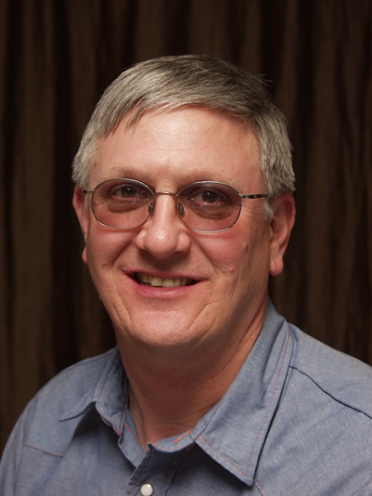

James served UIS as an electrician, and was hired in preparation for the Y2K potential disasters. Originally, he was only supposed to be here for two months…twenty years later, we are glad that he decided to stick around and join us for the long haul. His kind gestures and unselfish generosity over the years are unparalleled, and many have stories of his service e and sense of humor, including when demolition was being done to renovate the Development Office and one employee was so upset there would be no lights in her office over the holiday break, he decided to hook up green Christmas lights over her desk…much to the chagrin of former facilities director Dave Barrows. This personality is not only why Jimmy won the Employee of the Month for March 2004, but also the Employee of the Year award! Although he told his colleagues that he wasn’t going to retire until he was at least 67 and a half, he ultimately decided that he wants to spend more time with his family. He is the proud husband of Vaughn, and loves talking about his twin grandchildren. His kind gestures and unselfish generosity over the years are unparalleled, and we all will greatly miss seeing him on campus with us. Congratulations James!

Susan Koch
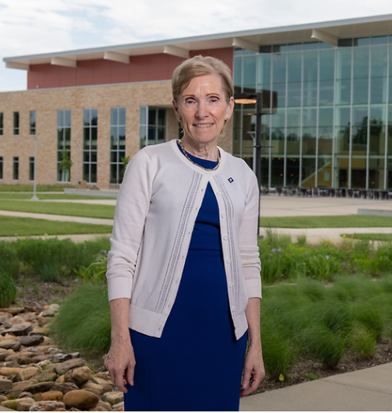
Dr. Susan Koch has served as Chancellor of the University of Illinois Springfield and Vice President of the UI System since 2011. During her tenure she has led the university to establish many new academic programs to enhance enrollment, visibility and reputation – including a partnership with Memorial Health System and the University of Illinois Chicago to add a Bachelor of Science degree in Nursing. She has strengthened the academic community with the recruitment of numerous faculty including two University of Illinois Distinguished Scholars. During her tenure the university has significantly enhanced the success of its young Division II Athletics program, including the addition of a new Cross Country program that has already produced the university’s first All American athlete. Dr. Koch has led successful fund-raising efforts to advance the university, provide student support and complete significant capital projects including the $21 million Student Union, a sustainable building that has won two national design awards. She has also secured private funding for important campus beautification projects including “The Young Lawyer,” a Lincoln sculpture by George Lundeen, a Shakespeare Garden that celebrates the university’s foundation in the Liberal Arts, and two major works of art for the Student Union.
With her leadership, UIS acquired Innovate Springfield, a downtown business and social innovation center as well as the UIS Field Station at Lake Springfield, which is used for environmental research and recreation. Dr. Koch also secured private support to launch “The Sangamon Experience," a regional history project and exhibit space.
A new Center for Lincoln Studies will follow in Fall 2020. The Chancellor has been active in the community with service on several boards including Memorial Health System. Dr. Koch earned a bachelor’s degree from Dakota State University and masters and doctoral degrees from the University of Northern Iowa. She also holds an honorary Doctorate in Public Service from Dakota State University.

Peggy Lister

Peggy Lister retired May 31, 2020 and had a long, productive, and respected career at the University. She started with the University in December of 1997 as an Account Tech II in University Payables. Due to the high quality of Peggy’s work, she was quickly promoted to an Account Tech III within a year. Later on, due to a re-organization of University Payables, Peggy ended up working for both University Payables as well as University Accounting and Financial Reporting (UAFR), splitting her time between both roles. In addition to maintaining her high quality of work within University Payables, she was able to quickly learn the ropes within UAFR and became the “go-to” expert in all issues related to State fund accounting. During this time, she was also able to successfully complete the necessary testing to earn a promotion to an Accountant II, which helped reflect the level of complex work that she performed. Eventually, Peggy transitioned completely to UAFR and she has been a full, valued team member of UAFR for many years now.

The large majority of Peggy’s work within UAFR dealt primarily with the complex accounting requirements surrounding State fund accounting, which includes numerous complex billing processes, reconciliations, and detailed analysis. One essential piece of these tasks involves a complex process of billing and vouchering thousands of transactions to the State of Illinois Comptroller’s Office, which enables the University to receive the $500M - $600M of annual State of Illinois appropriations that are appropriated to the University each year. We would not be able to receive this funding if it was not for Peggy’s hard work in this area. This process is very much “behind-the-scenes”, and most people are not aware of how complex, intricate, and detailed this process is. But it is absolutely **critical** to the University’s operations, and the demand for timely and accurate billing is extremely strong, going all the way up to the University’s Chief Financial Officer. As you can imagine, receiving $600 million of appropriations from the State of Illinois each year is absolutely critical to the University’s operations, and Peggy has been an absolutely essential piece in keeping this process operating smoothly for many years running now. The level of Peggy’s knowledge and skills over the intricacies of these processes and reconciliations are unmatched within UAFR, and she will be sorely missed!

Please help us congratulate Peggy Lister on a very well deserved retirement!

Scott Nafziger
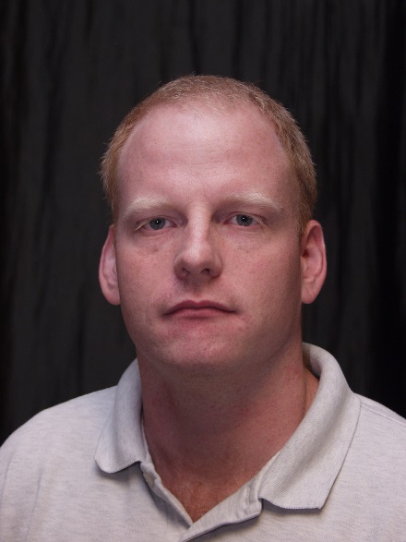
Scott Nafziger has seen many changes during his career at UIS. Scott started as a student at Sangamon State University in the early 90's. He lived in on-campus housing and was hired as a part-time computer lab supervisor. Eventually he was hired on full-time by Academic Computing.
Scott has changed positions and responsibilities over the years, adapting to the needs of the university. He knew his job inside and out, and he always provided valuable insight. He was a long-term thinker, asking "do you really want to do that?", if he thought a decision could lead to a problem years later.
Scott was the unofficial historian for ITS. He remembered how and when everything happened and who was involved. Later in his career Scott started teaching courses for the Computer Science department. He enjoyed sharing his knowledge and experiences with the students. Best wishes in your retirement Scott!

Laurel Newman
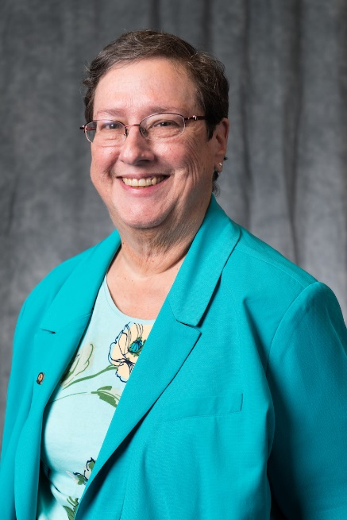
Laurel Newman earned her Ph.D. in Business Administration from the University of Illinois Urbana-Champaign and her M.B.A. from Lake Forest Graduate School of Management. She joined the UIS/UIS faculty in 1993 as an assistant professor in the Department of Management, and she was awarded tenure and promoted to associate professor in the Department of Business Administration in 2000.
Most recently, Dr. Newman served as the Executive Director of the Center for Academic Success and as Campus Ombuds. Prior to these roles, her appointments included Director of Online Programs for the College of Business and Management, and Department Chair. Professor Newman serves the community through board service on several area non-profits. She currently serves as the Board Chair for the South Central Illinois Chapter of the American Red Cross.
Dr. Newman’s disciplinary area is Organizational Behavior, and she has pursued research related to online learning, management education, work-life integration, cross-cultural adaptation and adaptation to change in the workplace. In 2015, she was a co-recipient of an Online Effective Practice Award from the Online learning Consortium for her leadership with COPE-l, the UIS Community of Practice in E­ learning. In 2011, Professor Newman received the Burks Oakley II Distinguished Online Teaching Award.

Jerry Peebles
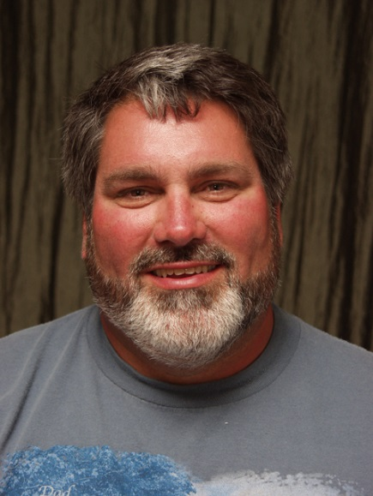
Jerry Peebles retired from UIS on June 30, 2019 after 27 years of service. He began working with the Grounds Crew as a Seasonal Grounds Worker on April 27th, 1992.
For those that don’t know Jerry, he could usually be seen during the warmer months operating our largest mower, which cuts the bulk of our campus turf areas. During the winter months, he was the primary snow plow operator, keeping us all safe on our campus roadways. Jerry is very knowledgeable and adaptable and was able to perform almost any task that the Grounds crew is responsible for and was always willing to lend a hand.
Jerry is a man of deep faith and is one of the kindest people that I have ever met. I’ve never seen him pass a member of the campus community without greeting them with a smile and a wave. He was always willing to pitch in to help anyone in need. Jerry went above and beyond every single day of his employment at UIS. He represented the University well and is missed very much by those of us who had the opportunity to know him.
Jerry, thank you for your many gracious and dedicated years of service.

Donna Rogers Skowronski
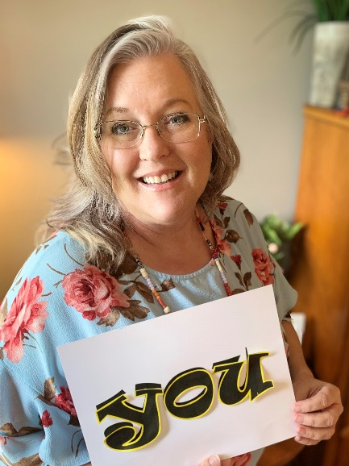

David Racine
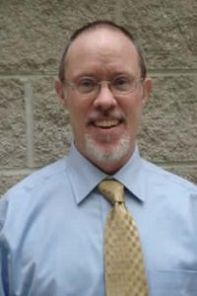
David Racine is the executive director of the Center for State Policy and Leadership on the Springfield Campus of the University of Illinois. In this role, which has held since 2010, he oversees public service and financing research, evaluation, and training programs, graduate internships in state government, public media coverage of state policy and politics, and Innovate Springfield, a local business and social innovation incubator. Racine has for several years been an active presence in the dissemination and implementation of innovative, evidence-based programs and practices in the education, health service, and social service fields. He helped to launch and for a number of years was the chief executive of Replication & Program Strategies, the first U.S. organization devoted exclusively to supporting the scale-up of effective programs. Previously, Racine was legislative director to Sen. Jack Danforth of Missouri, senior policy advisor for health, labor, and human services to Sen. Tom Kean of New Jersey, founding staff member and executive vice president of the Points of Light Foundation, and government affairs director for the American Public Human Services Association, the national organization representing state and local human service agencies.

Mark Roth
Mark Roth retired from UIS after 20 years of service as a Building Service Worker where he served the campus by keeping our stuff moving across the campus, setting up for the many events here at the university, and even working with keeping our campus recycling project running smoothly. Mark was one of our most visible employees and always enjoyed seeing all of the rest of the personnel while he worked. Congratulations on retirement Mark, all of F&S wishes you a fruitful retirement!

R. Steve Scott
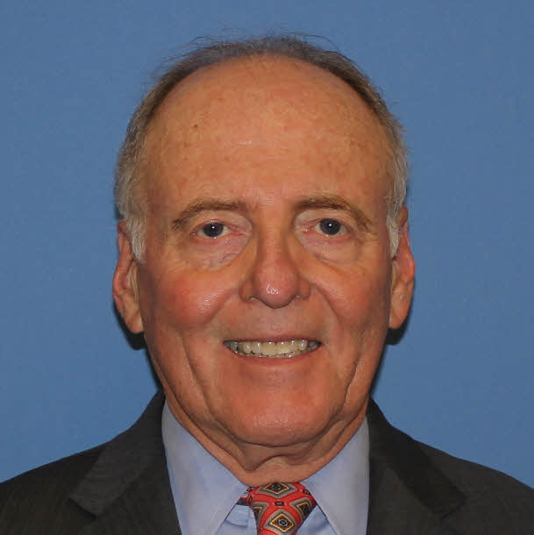

R. Stephen Scott, J.D., CPA, is a founding partner of Scott & Scott, P.C. Steve received a Bachelor of Science degree in accounting from Marquette University in 1972. He was qualified as a Certified Public Accountant by the University of Illinois in 1975, and graduated with honors from IIT-Chicago Kent College of Law in 1977, where he earned a Juris Doctor degree.

Steve is admitted to practice before the United States Supreme Court, the United States District Courts for the Central and Southern Districts of Illinois, the United States Tax Court, the United States Bankruptcy Court for the Central District of Illinois, and the Illinois Supreme, Appellate and Circuit Courts.

Steve has been an Associate Professor/Lecturer primarily of Commercial Law, but also Business Ethics for CPAs, and Fiduciary Taxation at the University of Illinois in Springfield (UIS), College of Business and Management. He taught in the Accounting Departments of UIS and its predecessor, Sangamon State University (SSU), since Spring, 1978, more than 42 years. He has recently retired from teaching, but still enjoys ongoing associations with many of the nearly 2,000 students he taught and the many teaching colleagues he has known over the years.

Steve holds leadership positions in several professional organizations. He is past President and a current director of the American Academy of Attorney-Certified Public Accountants (AAA-CPA), and Past Chair of the Corporate Law Departments Section Council of the Illinois State Bar Association. He is a member of and formerly served as the President and a Director of the Illinois Association of Attorney-Certified Public Accountants (IAA-CPA) and is a member of the American Inns of Court, Lincoln-Douglas Chapter. He is also a Regent of the American College of Attorney-Certified Public Accountants.

He has served the community through participation in civic, charitable and educational groups. He was President of Kids-at-Heart, Inc., which built and operated the Ronald McDonald House in Springfield, Illinois. He is currently a member of the Illinois Bar Foundation which supports attorneys in need and multiple groups providing legal assistance to those unable to pay for legal representation. Steve was formerly the Commodore of Island Bay Yacht Club and President of the Springfield Ski Club. He was a member of the Board of Directors of the Sangamo Club.

Steve concentrates his law practice in Estate Planning and Administration, Corporate and Commercial Law, Taxation and Tax Court, Real Estate, Commercial Bankruptcy (primarily Chapter 11 cases), and Commercial Litigation. He is rated “AV Preeminent” by Martindale-Hubbell in both legal ability and ethical standards. He has frequently lectured for the American Business Institute and participates in estate planning lectures with the AAA-CPA, and various financial organizations.

Robert Wright
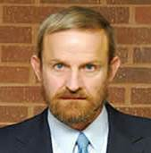
Robert Wright received the Ph.D. in Business Administration, with a major in Marketing, from Indiana University in 1991. He began teaching at UIS/SSU in fall 1991. Dr. Wright was tenured and promoted to associate professor in 1997 and promoted to full professor in 2004.
Professor Wright’s drive for excellence in scholarship led to 38 articles in well-regarded academic publications, and his scholarship contributed to the college’s efforts to obtain and maintain AACSB accreditation. Dr. Wright spent a significant amount of time mentoring new faculty in how to balance the demands of scholarship and teaching. His diverse teaching experience at UIS included courses across levels, times, locations, and delivery modes. Professor Wright’s successful scholarship and teaching activities were recognized by the University of Illinois in 2001, when he was named the UIS University Scholar.
Dr. Wright was highly engaged in service activities for department, college, and university over his 28 years at UIS/SSU. In addition to serving as a member of many committees, including the college’s Executive Committee, he undertook leadership responsibilities for Academic Freedom and Tenure, Campus Athletics and Recreation, and Campus Student Life Committees, as well as multiple Post Tenure Review Committees. Dr. Wright's service includes work with the Springfield business community for many years in his role as Chair of the Business Education Advisory Committee.

