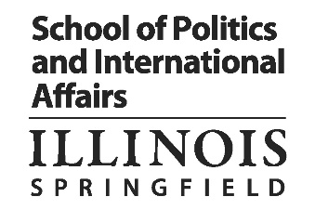
Name/ UIN:

Political Science Master’s Degree: Student Course Plan

Please create your draft course plan below, noting the year and semester you plan to take each of the following courses:

PSC 501 – Introduction to the Graduate Study of Politics (4 credit hours)
PSC 502 – Methods of Inquiry (4 credit hours)
PSC 590 – Closure Exercise (4 credit hours) Taken last semester
Electives (28 credit hours)
- A maximum of 12 credit hours can be at the 400-level (a minimum of 16 hours must be taken at the 500 level).
- Only 8 credit hours can be taken outside of the Political Science Department, and must be approved by your faculty advisor.
- A maximum of 8 internship credit hours can be applied toward the degree as electives.
- Students whose condition of admission required them to successfully complete PSC 451: Empirical Political Analysis (4 credit hours), may count PSC 451 towards their elective requirements.

Draft Course Plan
- Year 1 – Fall Semester:
- Year 1 – Spring Semester:
- Year 1 – Summer Semester:
- Year 2 – Fall Semester:
- Year 2 – Spring Semester:
- Year 2– Summer Semester:
- Year 3 – Fall Semester:
- Year 3 – Spring Semester:
- Year 4 – Fall Semester:
- Year 4 – Spring Semester:

